SAINT PATRICK’S CATHOLIC PRIMARY SCHOOL, WIGAN

Monday 9th December 2024

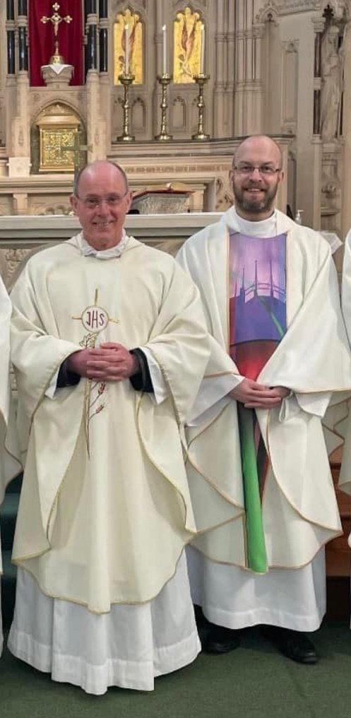
Dear Parents and Carers,
With sadness, we would like to share with you a recent announcement made by The Archbishop of Liverpool. With effect from early January, Archbishop Malcom has asked Father O’Shea to take up a new appointment as Parish Priest of Burscough and Parbold. Archbishop Malcolm has appointed Father Paul Grady as our new Parish Priest and Father Hugh Donleavy will remain as our Assistant Priest.
Father Paul may well be known to some of you already: originally from Wigan, he is a former pupil of St John Fisher Catholic High School and was ordained to the Priesthood in 2012. Currently serving in Leigh, Father Paul has been a frequent and welcome visitor to St Patricks over recent years; particularly on St Patrick’s Day and May Crowning Celebrations.
We are incredibly grateful to Father O’Shea and appropriate celebrations will take place in the coming weeks to mark his contributions to our Catholic Life and Mission. We would like to invite you to join us, as we say ‘Thank You and Farewell’ to Father O’Shea, at a whole-school Mass of Thanksgiving at 9:30am, on Thursday 9th January 2025, at 9:30am.
Fr O’Shea and Fr Paul on Saint Patrick’s Day 2022
Looking to the future, we are looking forward to meeting and working with Father Paul to continue all that has been developed in recent years and to further strengthen home, school and church links here at St Patricks. Please note that we are unable to confirm the dates of any future Liturgies, such as Ash Wednesday or First Holy Communion Masses, until Father Paul arrives.
Please remember the Clergy in your prayers as they prepare for their new appointments and for a smooth transition within the Parish of Saint William.
Yours faithfully,
Mrs L. Hobden

