
W
Newsletter - Week Beginning 5/11/2018
Dates, times and events are correct at the time of publication of this newsletter (though may be subject to some alterations or additions).
St. Patrick's
Catholic Primary School


Star of the week –
Week beginning 29.10.2018

Nursery | Harley Murphy  Austin Porter  Poppy Parker  George France | RH | Michael Irving
Nursery | Harley Murphy  Austin Porter  Poppy Parker  George France | RML | Talia Alzain
Y1H | Layton Pennington | Y4DM | Wiktor Pieda
Y1L | Tony Tran | Y4JM | Harvey Jones
Y2H | Alex Stroud | Y5E | Benjamin Morgowski
Y2C | Nathan Ashton | Y5K | Layton Robinson
Y3M | Ruo Chen | Y6G | Alanna Cross
Y3B | Valentinus Kubilius | Y6P | Isaac Brown

Top attended classes for the previous week 29.10.2018 | Class | Attendance %
1st | Y2KC | 100%
2nd | Y1HH | 99.13%
3rd | Y2HH | 99.09%
Whole school current academic year


96.35 %

Liam Sixsmith Y6
Excellent writing
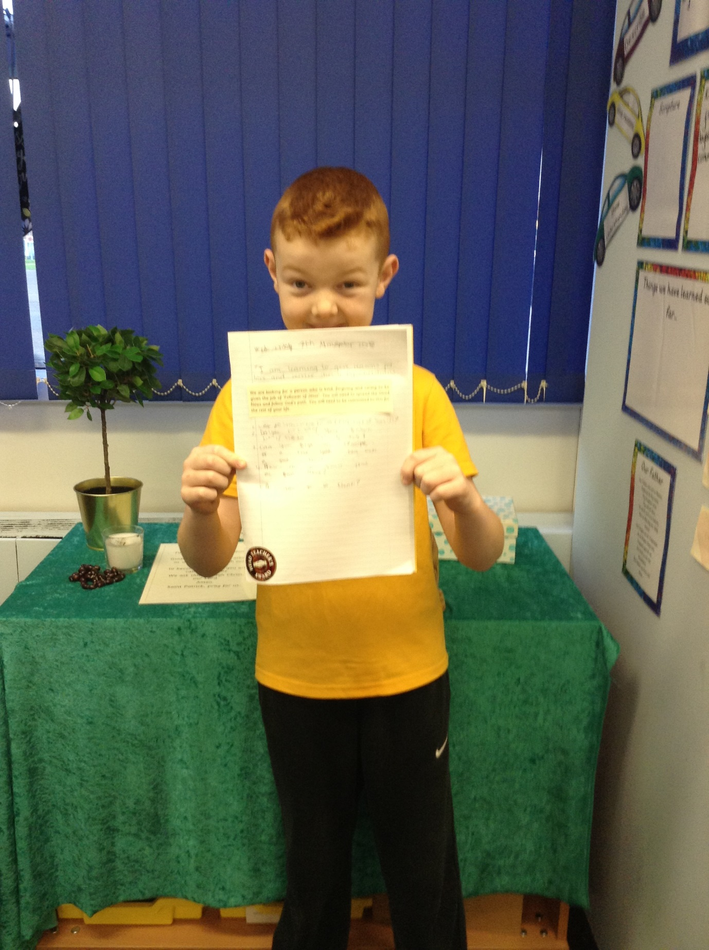
Brooklyn Banks Y5
Super R.E work!

Headteacher Awards this week:

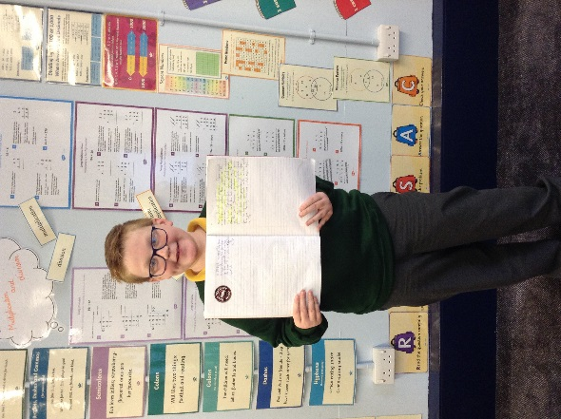



We will b Saturday 16th June 2018

Y4 Children who have taken part in this year’s Sacramental Preparation Programme will make their First Holy Communion in a special Mass. The Mass starts at 10am in St Patrick’s Church.
This will be a wonderful celebration for school and parish.
e processing into church from school at 1:45. Mass will start at 2pm. We his being a great parish and school celebration of our patron saint’s day.

YY

Community
Important Dates
13.11.2018- WCPSD open evening 4-6 pm Anyone interested in becoming a primary school teacher.

14.11.2018- STEPS parent class in the training room (6 weeks)

15.11.2018- Y5 children to attend church

16.11.2018- Children in Need: Whole school non-uniform day £1 donation

26.11.2018- Y2 children visiting the museum of Wigan life to explore artefacts.

27.11.2018- Y4 children visiting the museum of Wigan life to take part in a Roman workshop.

7.12.2018- Christmas Market in junior hall.

In class this week
Year 4 have completed some fieldwork at the canal area to support their topic of ‘localities’. At the location, the children identified and took photographs of physical and human features, whilst also examining habitats and suitability.
Wigan Catholic Primary School Direct

Could you be one of tomorrow’s outstanding teachers?

Join us at our open evenings at;
St Patrick’s Catholic Primary School, Hardybutt’s, WIGAN, WN1 3RZ

Tuesday 13th November 2018, 4-6:00pm
Tuesday 11th December 2018, 4-6:00pm
Tuesday 15th January 2019, 4-6:00pm
Tuesday 12th February 2019, 4-6:00pm

The course is accredited with
study days at Liverpool Hope
University leading to a PGCE
and QTS in primary teaching.

