
W
Newsletter - Week Beginning 3/12/2018
Dates, times and events are correct at the time of publication of this newsletter (though may be subject to some alterations or additions).
St. Patrick's
Catholic Primary School


Star of the week –
Week beginning 26.11.2018

Nursery | Sophie Whyte  Cooper Hart  Liliana Zuchowska  Finlay Horrigan | RH | Mawaddah Sawagogo
Nursery |  | RML | Sophina Ashton
Y1H | Addison Groenewald | Y4DM | Mark Bamber
Y1L | Poppy Glaze | Y4JM | Amy Lilley
Y2H | Jake Hunter | Y5E | Melarnie Kendrick
Y2C | Isaac Westergren | Y5K | Elvin Justin
Y3M | Jacob Taylor | Y6G | Shakira O’Reilly
Y3B | Tee-Jay Sharrock | Y6P | Brooke Eccles
Top attended classes for the previous week 26.11.2018 | Class | Attendance %
1st | RML | 99.13%
2nd | Y5k | 99.05%
3rd | RH | 98.57%
Whole school current academic year


96.01%

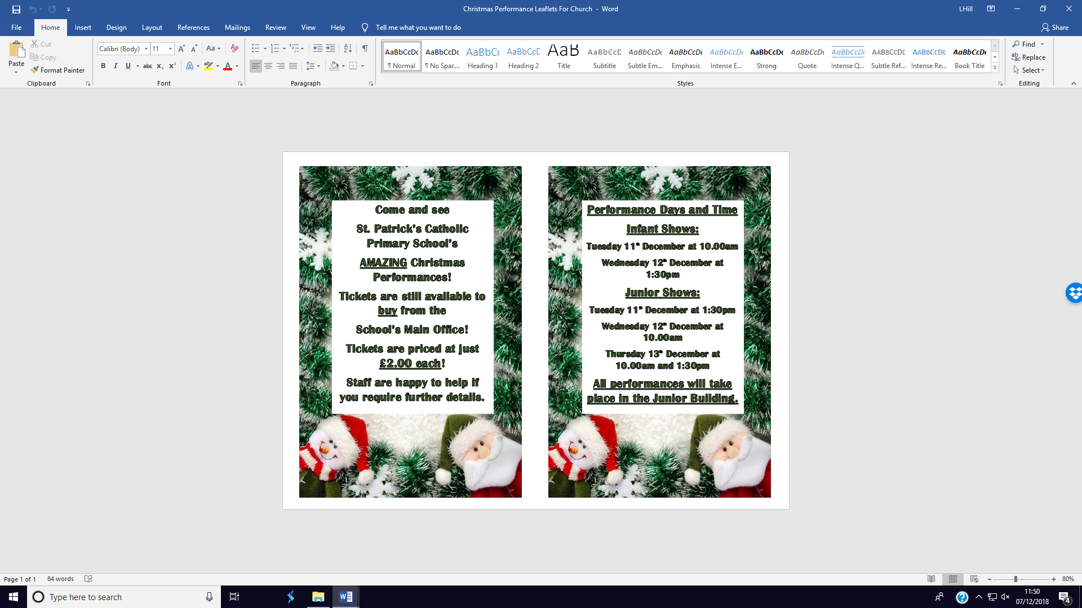

Headteacher Awards

Fantastic work this week from Charlie Y2, Cristian Y4 & Daisy Y5
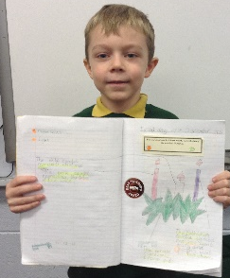
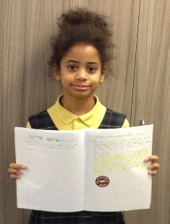
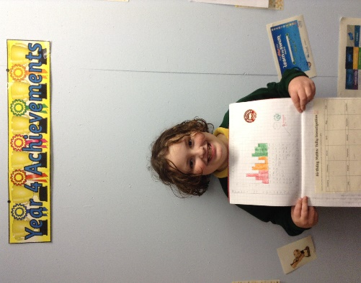

Community & In Class this Week

Friday 7th December was St. Patrick’s annual Christmas Market. The event was a huge success, as always.
Huge thank you to everyone involved!

We will b Saturday 16th June 2018

Y4 Children who have taken part in this year’s Sacramental Preparation Programme will make their First Holy Communion in a special Mass. The Mass starts at 10am in St Patrick’s Church.
This will be a wonderful celebration for school and parish.
e processing into church from school at 1:45. Mass will start at 2pm. We his being a great parish and school celebration of our patron saint’s day.

Important Dates

11.12.2018 -13.12.2018 Christmas Performances.
14.12.2018- Christmas Jumper day for save the children. Children to come to school in Christmas jumper/dress £1.00. Money raised for save the children.
14.12.2018- Children’s Christmas Lunch.
17.12.2018- Christmas Disco
20.12.2018- Pantomime
21.12.2018- Christmas Service in church. Church open from 12:45pm. Service begins at 1pm. Children to be collected from 2pm at school.
24.12.2018- St. Patrick’s Church Children & Family Mass 5:00pm
25.12.2018- St Patrick’s Church Mass 9:15am

Community

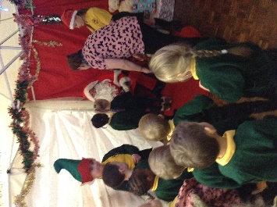
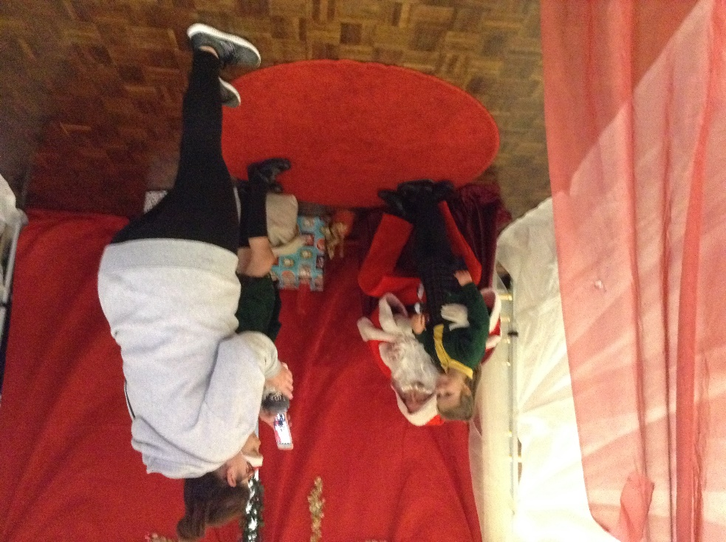
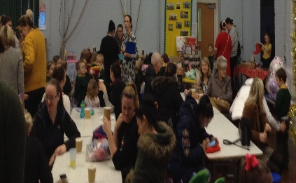

Running total: £603 (Raffle tickets for the Unicorn are still on sale)

