
W
Newsletter - Week Beginning 29/10/2018
Dates, times and events are correct at the time of publication of this newsletter (though may be subject to some alterations or additions).
St. Patrick's
Catholic Primary School


Star of the week –
Week beginning 8.10.2018

Nursery | Callum Gore  Lewie Rennox  Madeline Brown  Emily Eatock | RH | Zhelly Asiamah
Nursery | Callum Gore  Lewie Rennox  Madeline Brown  Emily Eatock | RML | Isabelle Rolle
Y1H | Nina Duda | Y4DM | Ruby Wallis
Y1L | Maggie Gaskell | Y4JM | Oliver Hesketh
Y2H | Alice McKenna | Y5E | Archie Porter
Y2C | Caitlyn Horrogan | Y5K | Brooklyn Banks
Y3M | Charlie Reeves | Y6G | Megan Posterero
Y3B | Sophie Carrington | Y6P | Romey Richardson

Top attended classes for the previous week 8.10.2018 | Class | Attendance %
1st | YRH | 99.52%
2nd | Y3M | 99.09%
3rd | Y2C | 97.73%
Whole school current academic year


96.34%

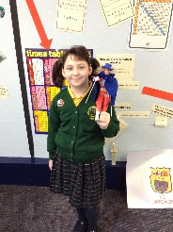

Mikayla Y4
For producing a fantastic model of Oliver Cromwell for her homework.

Alex Mosley Y2
For his excellent maths work identifying and drawing lines of symmetry.
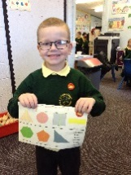
Headteacher Awards this week:



5.11.2018- Class school photographs
7.11.2018- STEPS parent class in the training room (6 weeks)
8.11.2018- Y4 children to attend church
16.11.2018- Children in Need: Whole school non-uniform day £1 donation
5.11.18 Dolce are offering a special Bonfire menu:
Hot dog with Fried Onions
Vegetarian Hot Dog with Fried Onions
Macaroni Cheese
Stuffed Jacket Potato
Oven Baked Wedges
Mixed Salad
Coleslaw
Sweetcorn
Tomato Ketchup
Chocolate Cookie
Iced Lemon Sponge
Fresh Fruit Salad
Yoghurt

We will b Saturday 16th June 2018

Y4 Children who have taken part in this year’s Sacramental Preparation Programme will make their First Holy Communion in a special Mass. The Mass starts at 10am in St Patrick’s Church.
This will be a wonderful celebration for school and parish.
e processing into church from school at 1:45. Mass will start at 2pm. We his being a great parish and school celebration of our patron saint’s day.

YY

In class this week
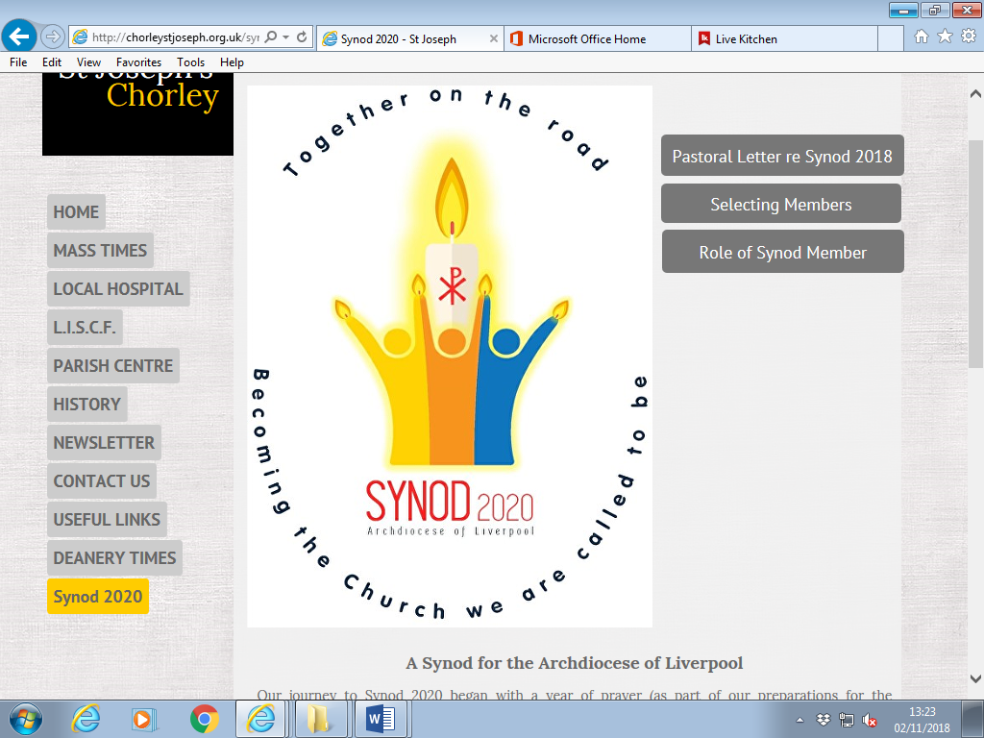

On Friday 12th October 2018, St. Patrick’s community celebrated ‘Harvest’ by collecting for local charity ‘The Brick’. Representatives from the charity were overwhelmed by the generosity and the amount of food collected.
Huge thank you to everyone who donated.

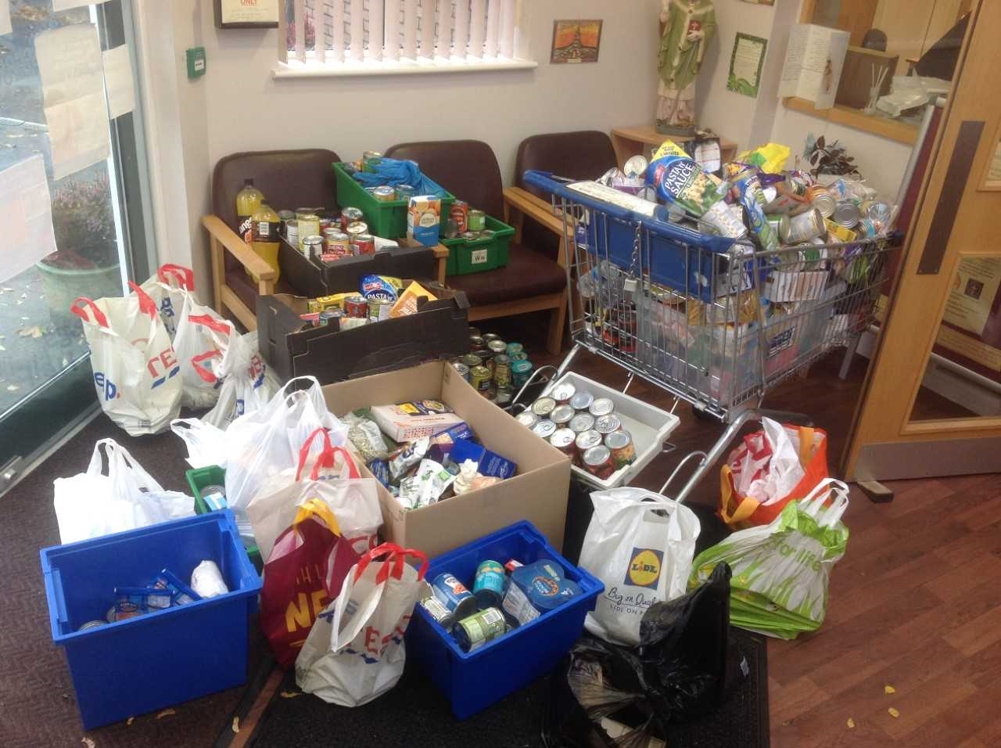

Community

This week, the children of St. Patrick’s took part in an assembly where they found out about SYNOD 2020.

