
W
Newsletter - Week Beginning 26/11/2018
Dates, times and events are correct at the time of publication of this newsletter (though may be subject to some alterations or additions).
St. Patrick's
Catholic Primary School


Star of the week –
Week beginning 19.11.2018

Nursery | Daren Abdullah  Ella Dawber  Aya Baraka  Lewie Rennox | RH | Harley  Starkie
Nursery | Daren Abdullah  Ella Dawber  Aya Baraka  Lewie Rennox | RML | Grace Armstrong
Y1H | Malika Houghton | Y4DM | Harry Tran
Y1L | Nathan Igbinola | Y4JM | Oliver Irving
Y2H | Lilly Mailey | Y5E | Jacob Kenyon
Y2C | Alise Gordijenko | Y5K | Lauren Simm
Y3M | Jacob Grainger | Y6G | Kia Sheridan
Y3B |  | Y6P | Lily Schofield

Top attended classes for the previous week 19.11.2018 | Class | Attendance %
1st
2nd
3rd
Whole school current academic year



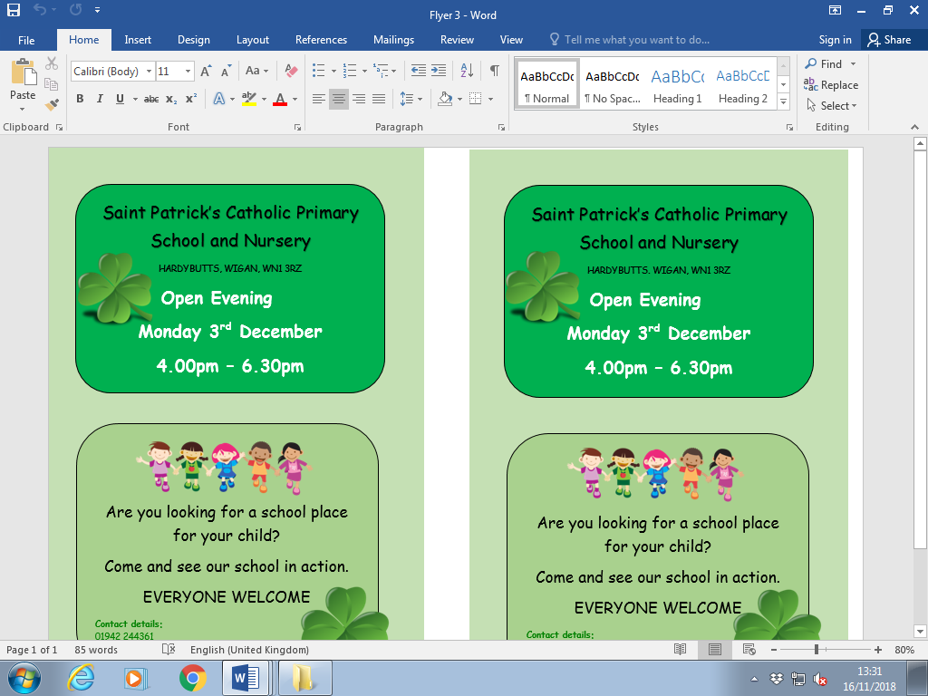
Headteacher Awards this week:


Well done Layla Jamieson our first Nursery ‘Golden Ticket’ winner.
For her exceptional behaviour.


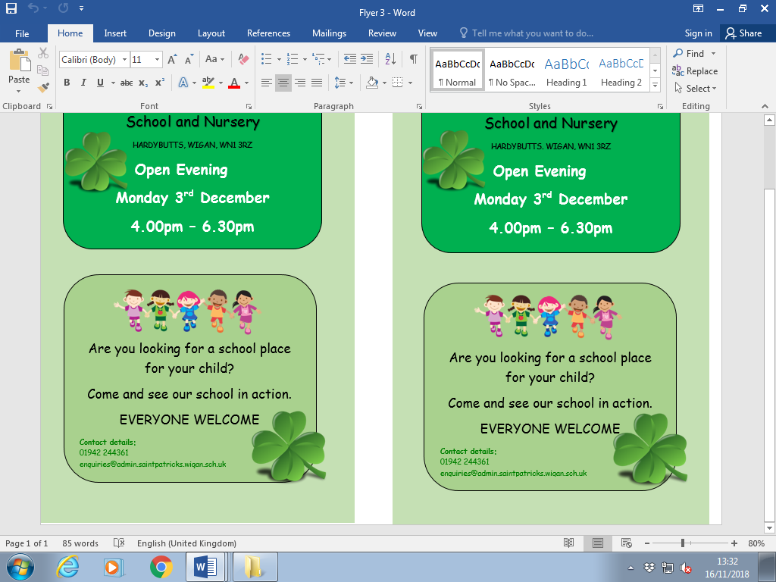

.

Important Dates

3.12.2018- School open evening 4:00-6:30pm. All welcome, parents looking at a school for their child.
6.12.2018- Y6 children to attend church

7.12.2018- Christmas Market in Infant hall.
11.12.2018 - 14.12.2018- Christmas Performances
14.12.2018- Christmas Jumper day for save the children. Children to come to school in Christmas jumper/dress £1.00. Money raised for save the children.
14.12.2018- Children’s Christmas Lunch
21.12.2018- Christmas Carol service in church 1pm-2pm doors open from 12:45. Children to be collected at 2pm from school.

Community

Hospice toys will be on sale in school from Monday 3/12/18. These cost £2 each and will be available to purchase in teaching units.

Tickets go on sale on Monday 3/12/18 for the Christmas disco. Tickets cost £2 each and will be available to purchase from the school office.
We will b Saturday 16th June 2018

Y4 Children who have taken part in this year’s Sacramental Preparation Programme will make their First Holy Communion in a special Mass. The Mass starts at 10am in St Patrick’s Church.
This will be a wonderful celebration for school and parish.
e processing into church from school at 1:45. Mass will start at 2pm. We his being a great parish and school celebration of our patron saint’s day.

YY

Community

In class this week

