
W
Newsletter - Week Beginning 19/11/2018
Dates, times and events are correct at the time of publication of this newsletter (though may be subject to some alterations or additions).
St. Patrick's
Catholic Primary School


Star of the week –
Week beginning 12.11.2018

Nursery | Jacob Rigby  Mason Cain  Layla Jamieson  Aaliyah Youseef | RH | Jack Unsworth
Nursery | Jacob Rigby  Mason Cain  Layla Jamieson  Aaliyah Youseef | RML | Lilly-May Dale
Y1H | Ava O’Hara | Y4DM | Ellis Ramsdale
Y1L | Phoebe Wallis | Y4JM | Alex Hobden
Y2H | Charlie Armstrong | Y5E | Connor Gregory
Y2C | Charlie Rennox | Y5K | Niemah Sawadogo
Y3M | Hannah Else-Harlow | Y6G | Kajus Jankauskas
Y3B | Jessica Liptrot | Y6P | Zeke Edwards

Top attended classes for the previous week 12.11.2018 | Class | Attendance %
1st | Y2KC | 99.09%
2nd | Y1HH | 98.26%
3rd | Y1KL | 98%
Whole school current academic year


96.16%

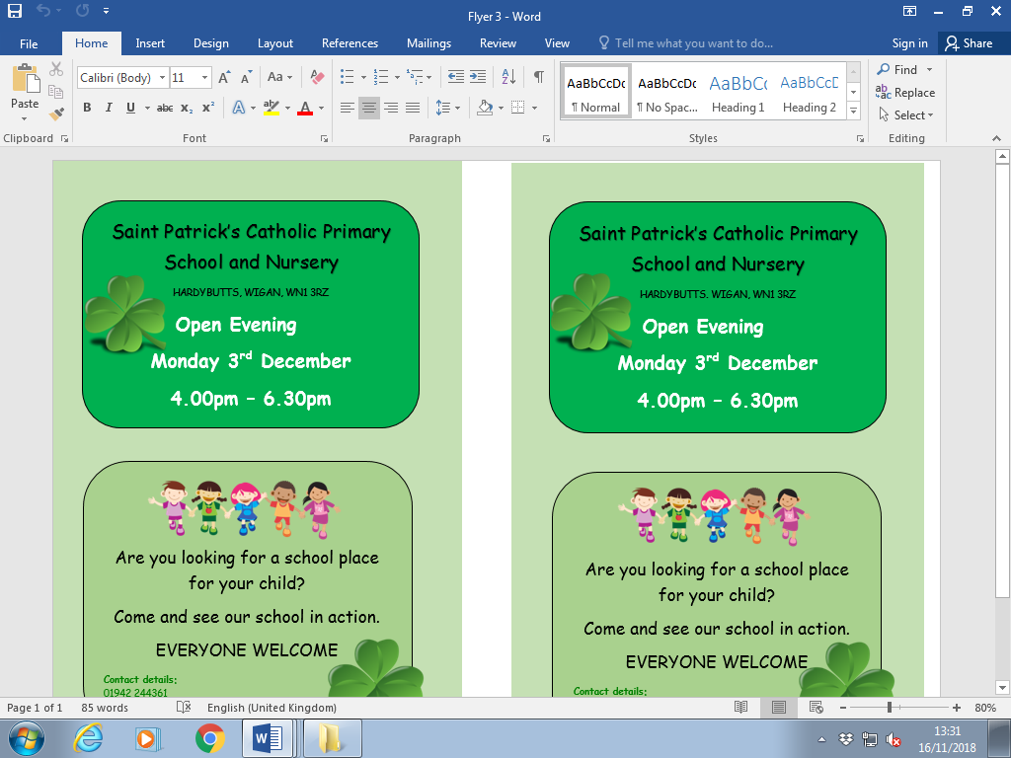
Headteacher Awards this week:

Lukas and Grace in Reception for amazing independent writing.

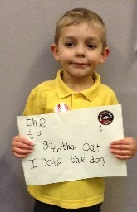

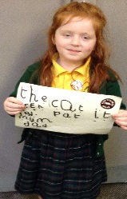
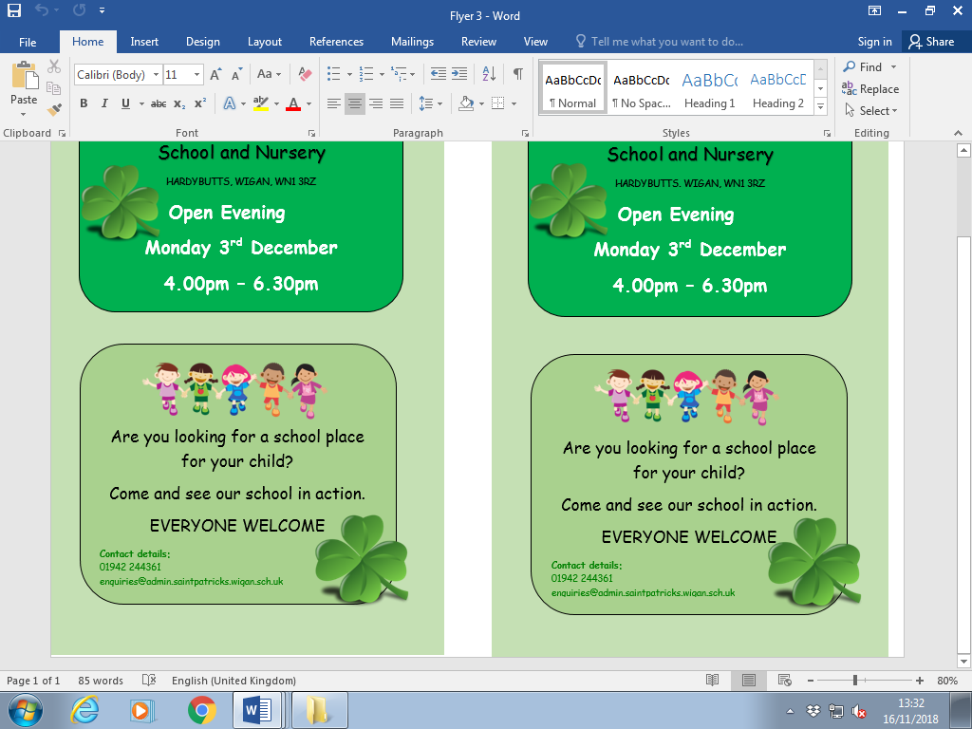

.

YY

Community
We are continuing to raise money throughout the month of November for ‘The Royal British Legion’ Poppy appeal.
We have been given stationary items to sell to help raise money.
They will be on sale at the school office during the morning break and start and end of the school day.
Rubbers, pencils and sharpeners 50p each
Rulers £1.00.

We will b Saturday 16th June 2018

Y4 Children who have taken part in this year’s Sacramental Preparation Programme will make their First Holy Communion in a special Mass. The Mass starts at 10am in St Patrick’s Church.
This will be a wonderful celebration for school and parish.
e processing into church from school at 1:45. Mass will start at 2pm. We his being a great parish and school celebration of our patron saint’s day.

Important Dates

26.11.2018- Y2 children visiting the museum of Wigan life to explore artefacts.

27.11.2018- Y3 children visiting the museum of Wigan life to take part in a Roman workshop.
29.11.2018- Y3 children to attend church
3.12.2018- School open evening 4:00-6:30pm. All welcome, parents looking at a school for their child.

7.12.2018- Christmas Market in Infant hall.
14.12.2018- Christmas Jumper day for save the children. Children to come to school in Christmas jumper/dress £1.00. Money raised for save the children.
14.12.2018- Children’s Christmas Lunch.

In class this week

Pudsey Bear came to visit Nursery!

He lost his spotty eye patch …

… but the Nursery children helped
him find it. Well done children!

Community
