
W
Newsletter - Week Beginning 12/11/2018
Dates, times and events are correct at the time of publication of this newsletter (though may be subject to some alterations or additions).
St. Patrick's
Catholic Primary School


Star of the week –
Week beginning 5.11.2018

Nursery | Charlie Schofield  Aya Baraka  Ezra Habgood- Conlin  George France | RH | Joey Hurst
Nursery |  | RML | Gustas Mitickinas
Y1H | Alexander Dudzik | Y4DM | Rihanna O’Reilly
Y1L | Miley Darbyshire Ward | Y4JM | Mikayla McCoy
Y2H | Alice Shawcross | Y5E | Holly Murphy
Y2C | Paige Brennan | Y5K | Lelenda Atakora
Y3M | Grace Abbott | Y6G | Chloe McCoy
Y3B | Lowyn Gregory | Y6P | Ella Robinson

Top attended classes for the previous week 5.11.2018 | Class | Attendance %
1st | RML | 99.57%
2nd | Y4DM | 99.05%
3rd | Y2KC | 98.64%
Whole school current academic year


96.27%

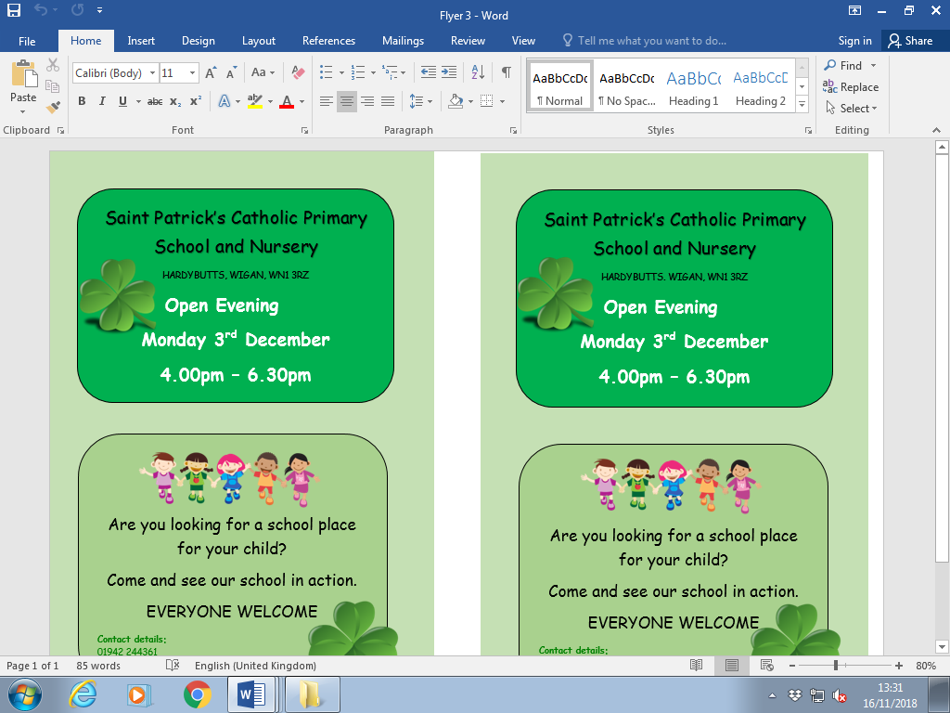
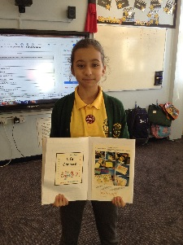
Headteacher Awards this week:

Daria Saeed
Excellent consistent presentation

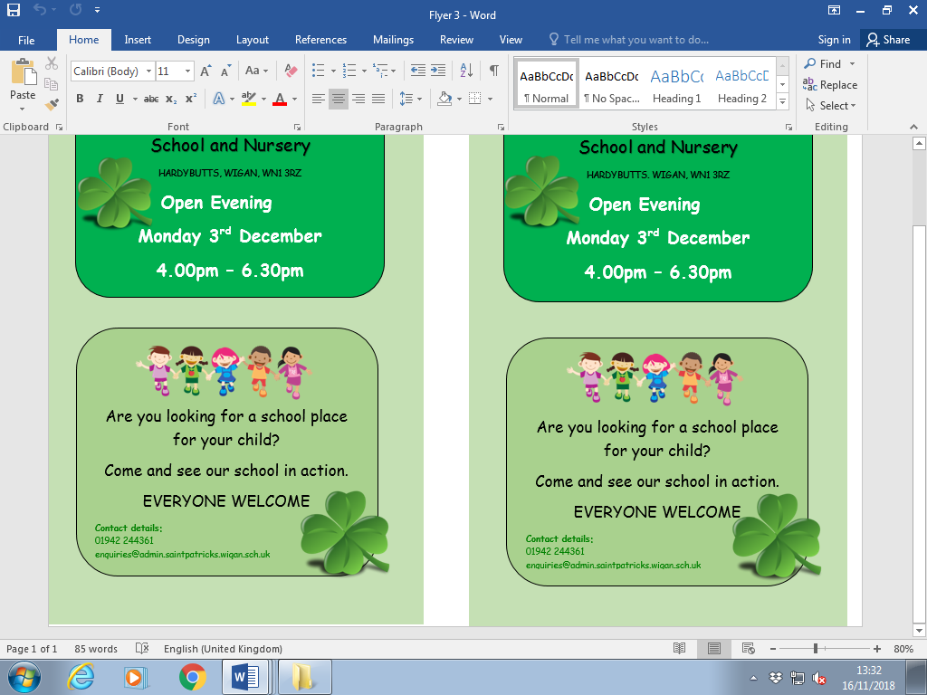


.

Important Dates

22.11.2018- Y6 children to attend church

26.11.2018- Y2 children visiting the museum of Wigan life to explore artefacts.

27.11.2018- Y3 children visiting the museum of Wigan life to take part in a Roman workshop.
29.11.2018- Y3 children to attend church
3.12.2018- School open evening 4:00-6:30pm. All welcome, parents looking at a school for their child.

7.12.2018- Christmas Market in Infant hall.
14.12.2018- Christmas Jumper day for save the children. Children to come to school in Christmas jumper/dress £1.00. Money raised for save the children.

Community
We are continuing to raise money throughout the month of November for ‘The Royal British Legion’ Poppy appeal.
We have been given stationary items to sell to help raise money.
They will be on sale at the school office during the morning break and start and end of the school day.
Rubbers, pencils and sharpeners 50p each
Rulers £1.00
We will b Saturday 16th June 2018

Y4 Children who have taken part in this year’s Sacramental Preparation Programme will make their First Holy Communion in a special Mass. The Mass starts at 10am in St Patrick’s Church.
This will be a wonderful celebration for school and parish.
e processing into church from school at 1:45. Mass will start at 2pm. We his being a great parish and school celebration of our patron saint’s day.

YY

Community

In class this week
Reception, Y1 and Y2 were excited to welcome Father O’Shea into school this week to help them role play the sacrament of Baptism.

