

St. Patrick's
Catholic Primary School

Newsletter - Week Beginning 2/9/2019
Dates, times and events are correct at the time of publication of this newsletter (though may be subject to some alterations or additions).

Welcome Back!

A very warm welcome back to everybody for the start of this new academic year. We look forward to the year ahead, working together to support all our children at St. Patricks.
Mrs Hobden

.



Jack Hopper Y4
Letter sent to school from a member of the public about his outstanding conduct on a day out in the holidays. “Jack is a credit to your school.”
Lewis Reeves Y6
For great presentation
Head lice
May I take this opportunity to ask for your support in the continuous battle with head lice. Head lice are a problem in many communities and do not reflect poor hygiene. Please could I ask you to support us by checking your child(ren) on a regular basis. Thank you for your continuing support.


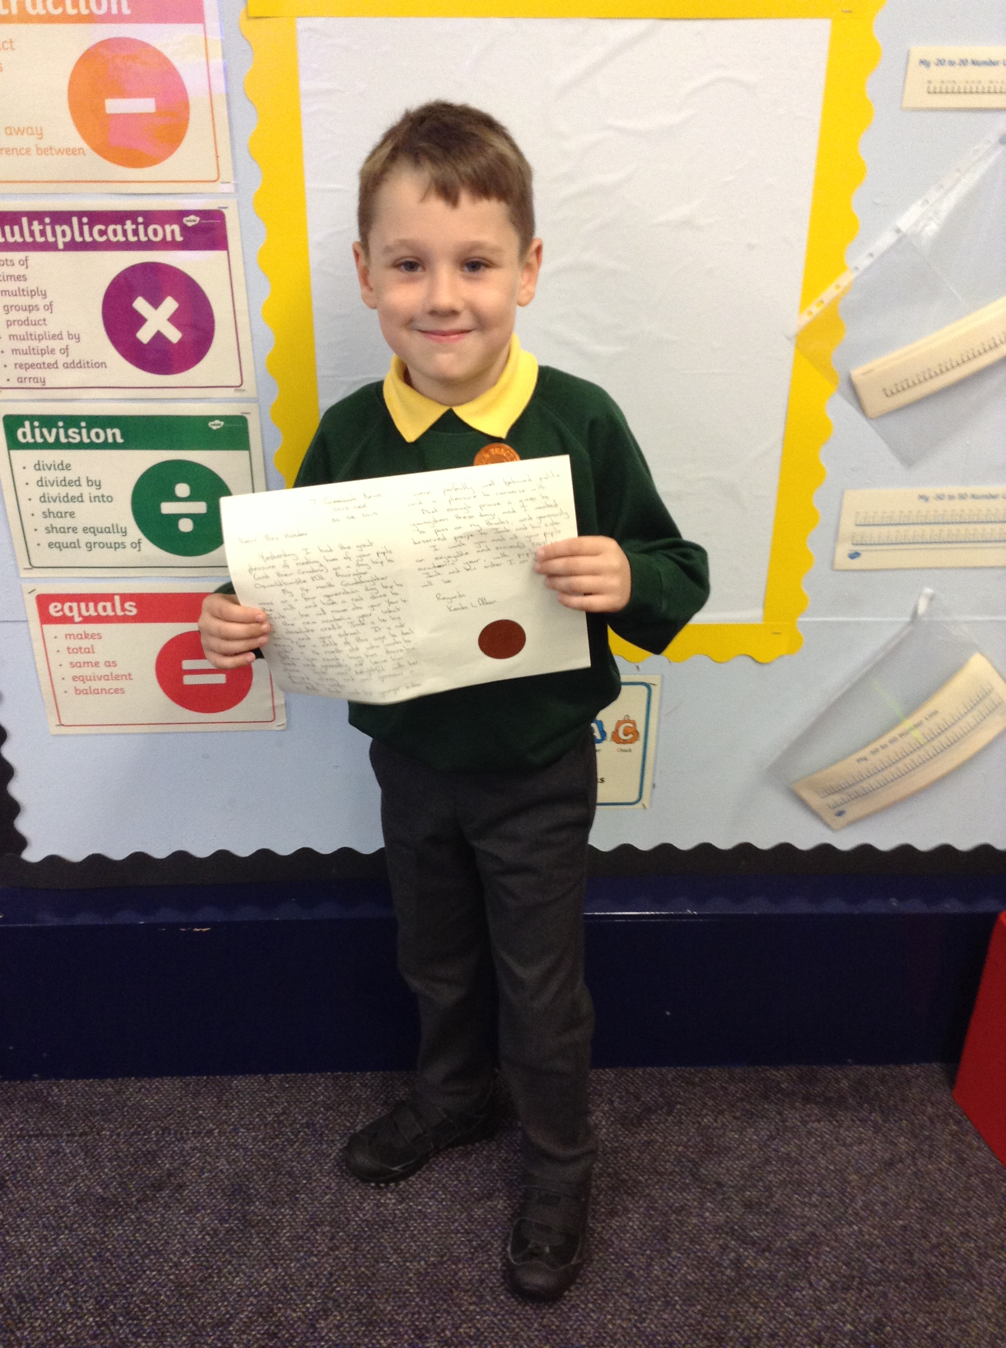
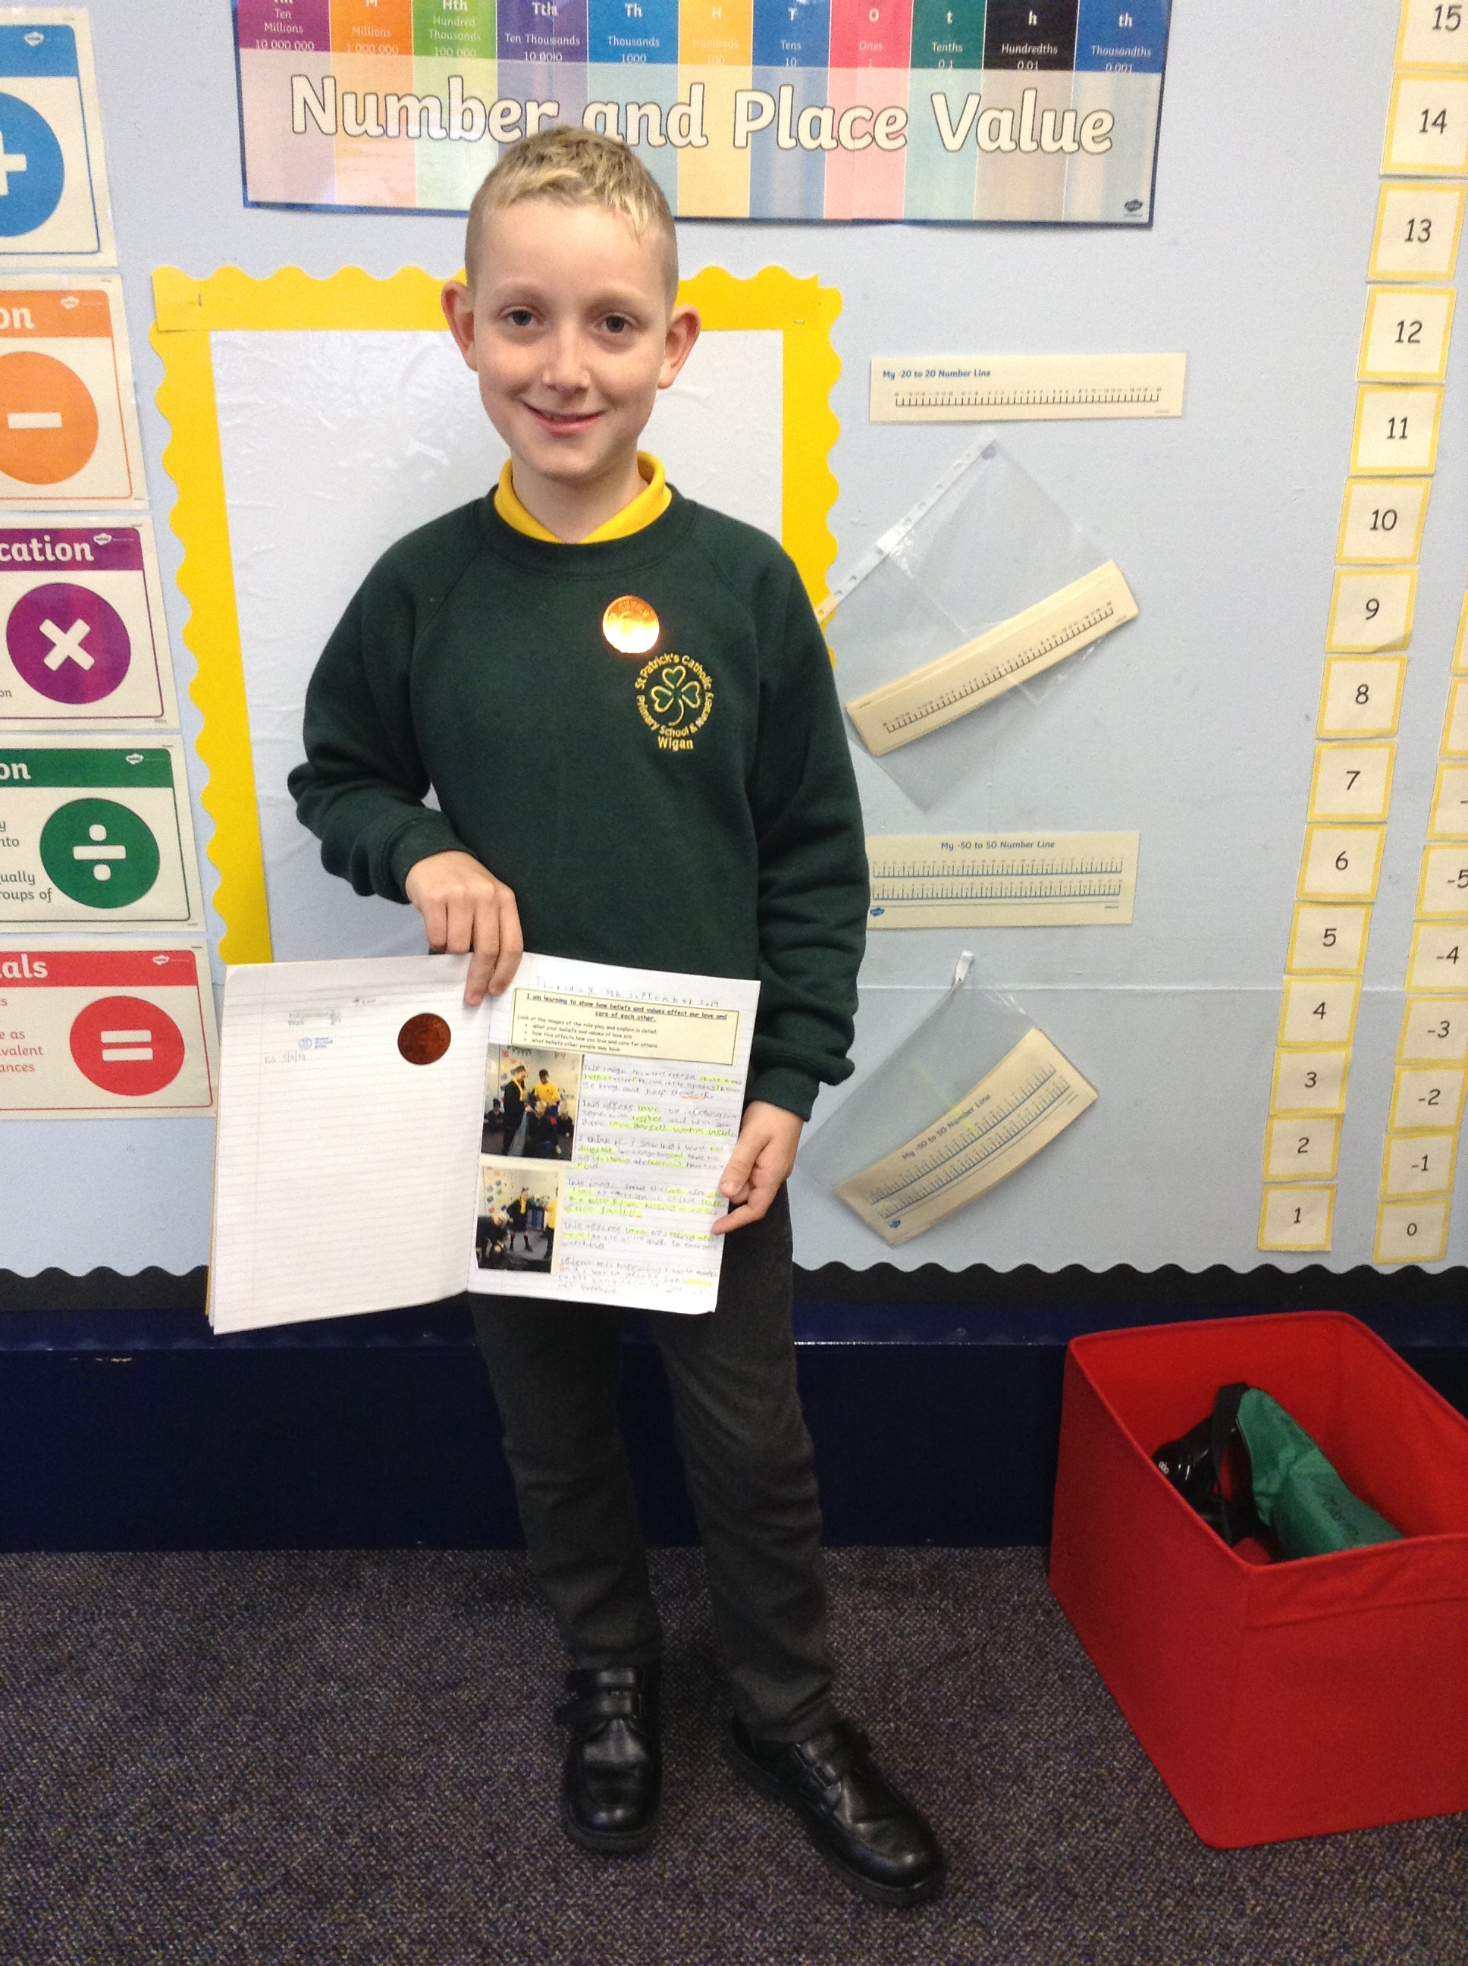

Events
We will b Saturday 16th June 2018

Y4 Children who have taken part in this year’s Sacramental Preparation Programme will make their First Holy Communion in a special Mass. The Mass starts at 10am in St Patrick’s Church.
This will be a wonderful celebration for school and parish.
e processing into church from school at 1:45. Mass will start at 2pm. We his being a great parish and school celebration of our patron saint’s day.

Community
In class this week
Year 2
YY

- 9.9.19-13.9.19- Y6 children residential at Boreatton Park
- 12.9.19-Y5 will be attending mass
- 12.9.19-Y4 will be holding a stay and pray at 9am for parents to join their children
- 19.9.19-Y4 will be attending mass
- 19.9.19-Y3 will be holding a stay and pray at 9am for parents to join their children
- 27.9.19- Macmillan Coffee morning.

Open Evening
Thursday 19th September 2019
6:00pm-8:30pm
All Welcome

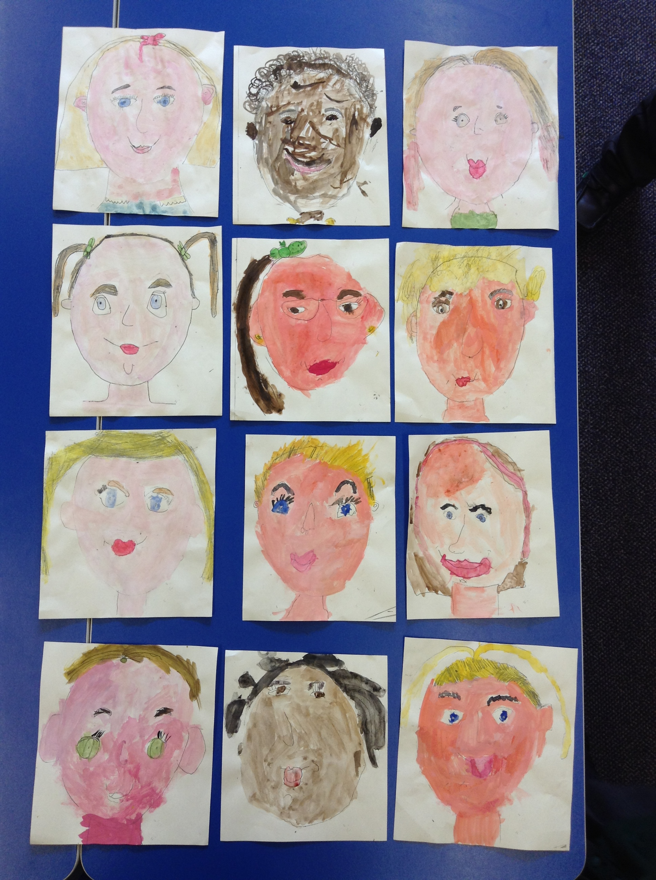

This week Year 2 have been getting creative and have sketched and painted their own self-portraits!

