
W
Newsletter - Week Beginning 8/10/2018
Dates, times and events are correct at the time of publication of this newsletter (though may be subject to some alterations or additions).
St. Patrick's
Catholic Primary School


Star of the week –
Week beginning 1.10.2018

Nursery | Finlay Horrigan  Hanna Cegielska  Isaac Sharratt  Eddie Fitzpatrick | RH | Jessica Maye
Nursery |  | RML | Annabella Edwardson
Y1H | Maysum Rooby | Y4DM | Kiera Dainty
Y1L | Nikolas Karac | Y4JM | Levi McDonough
Y2H | Electra Woodhouse | Y5E | Caitlin Rodgers
Y2C | Zak Edwardson | Y5K | Georgia Nicholson
Y3M | Florence McKenna | Y6G | Kajus Jankauskas
Y3B | Matilda Hart | Y6P | Kacper Jazdzewski

Top attended classes for the previous week 1.10.2018 | Class | Attendance %
1st | Y3M & Y4DM | 100%
2nd | Reception H | 99.52%
3rd | Y2H | 99.09%
Whole school current academic year


96.63%

Headteacher Awards this week:

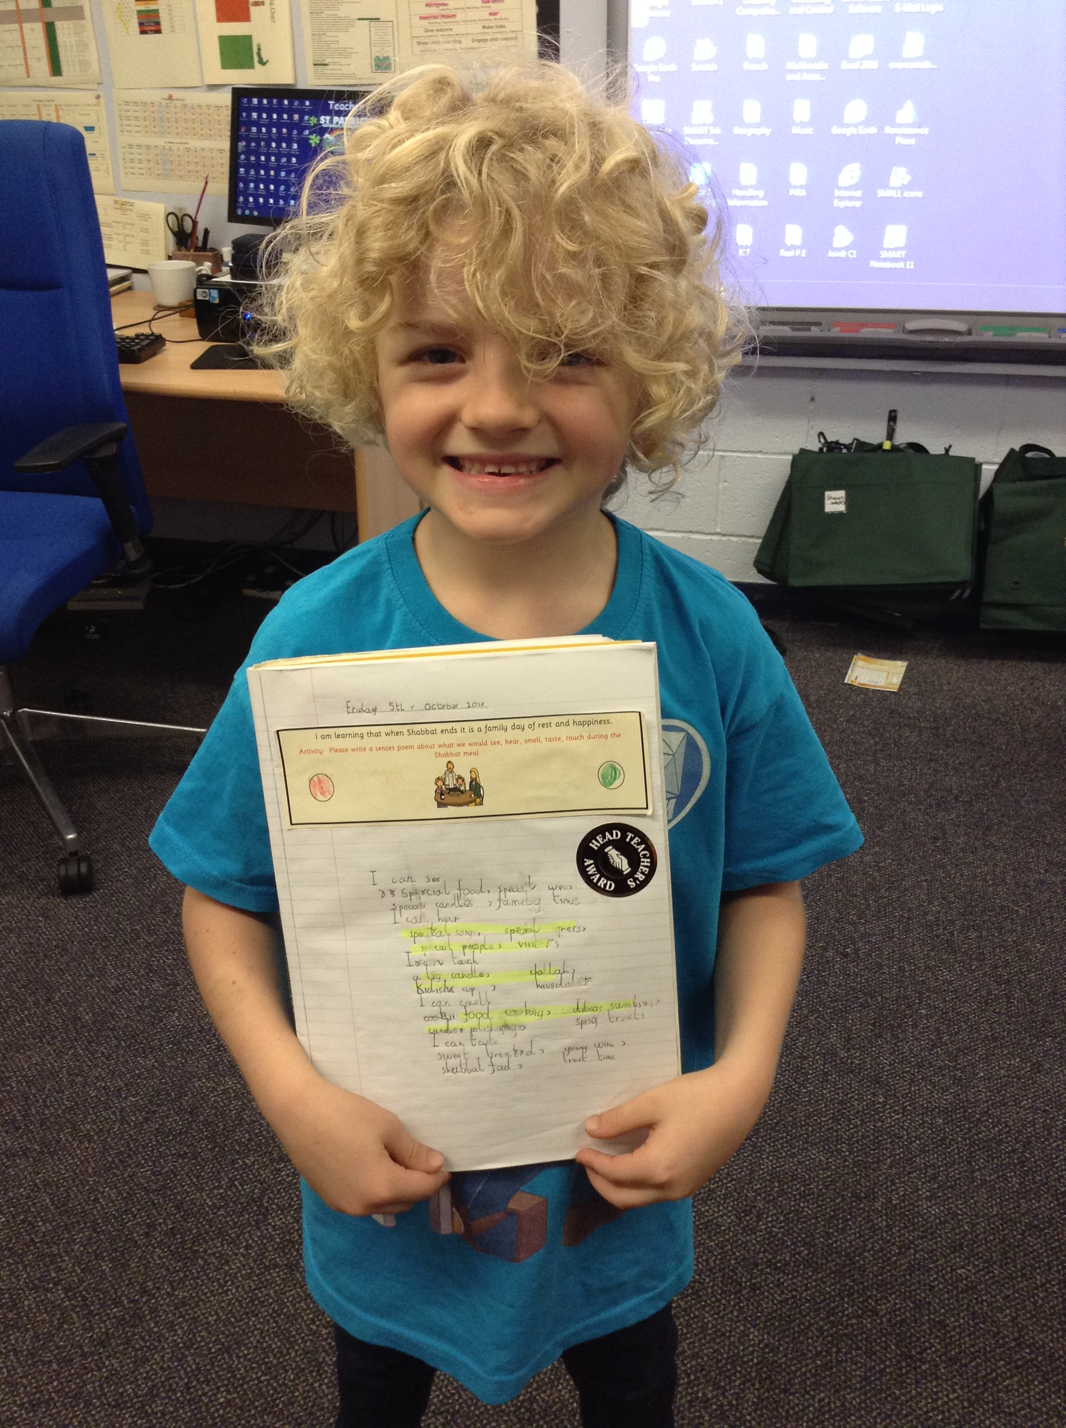
Thomas in Y2 produced fantastic RE work.
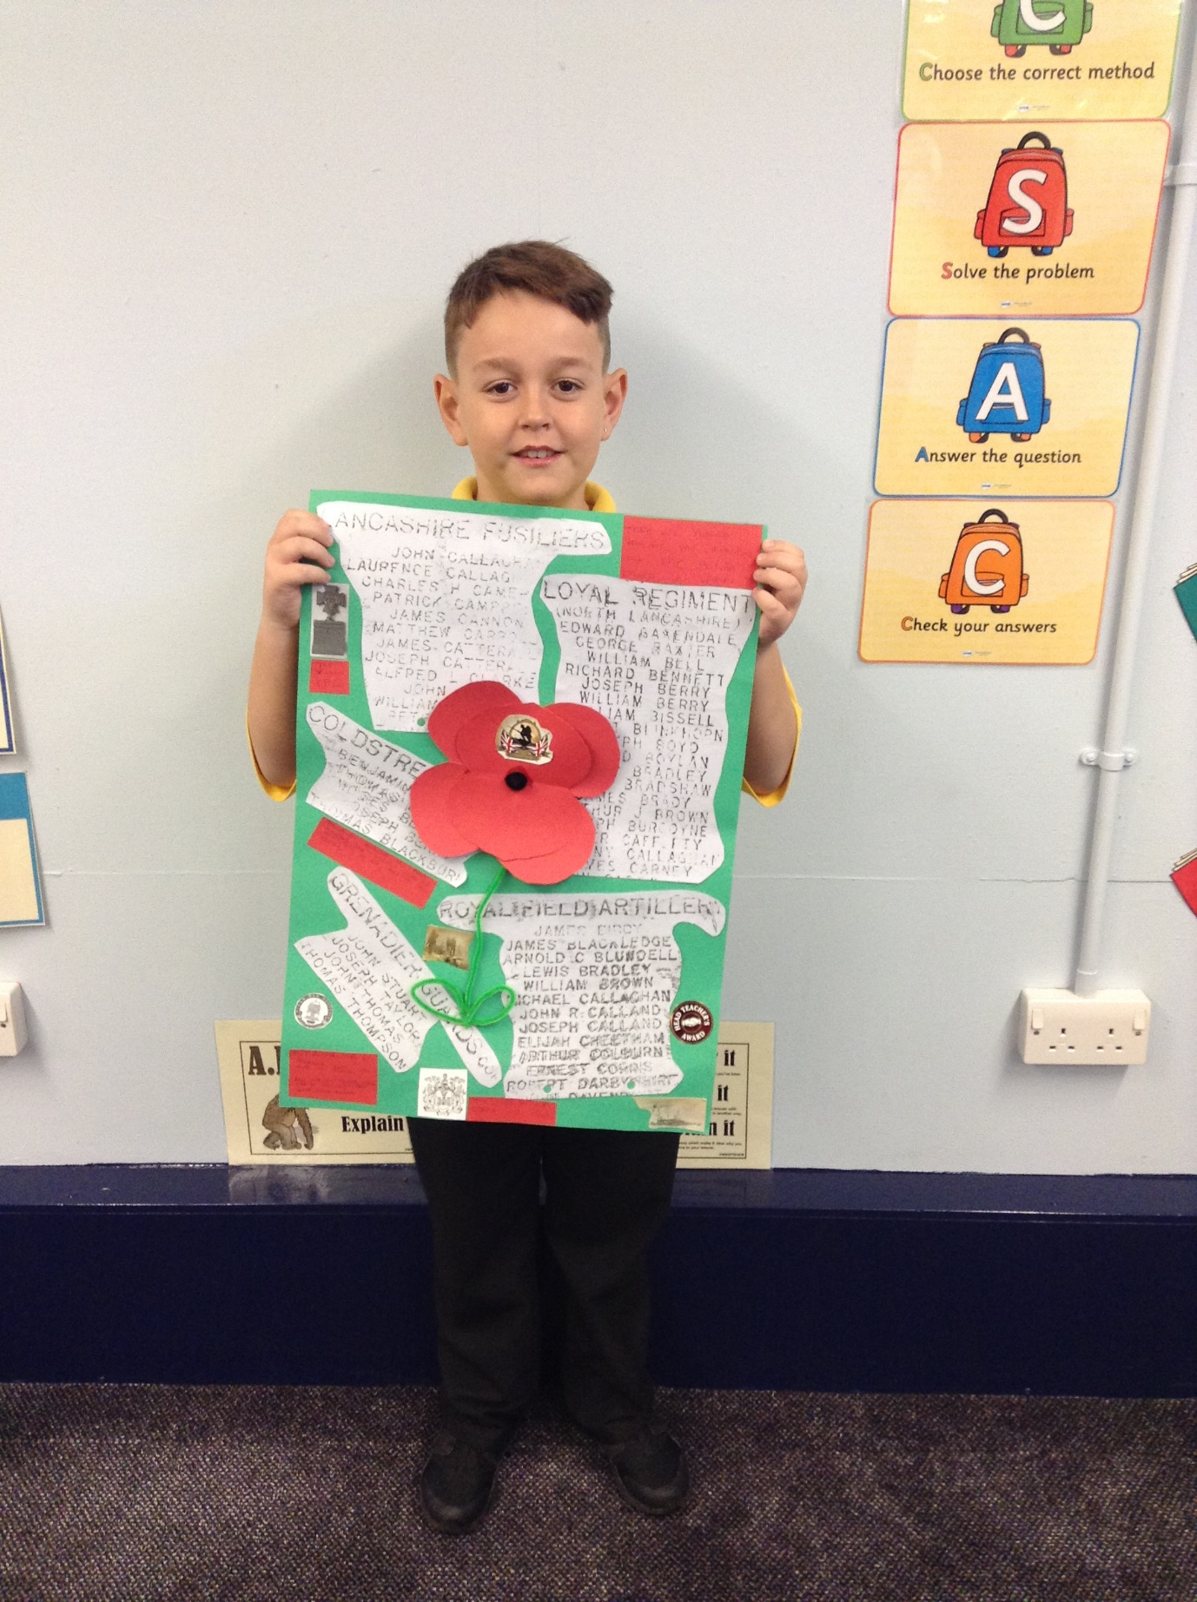
Harvey in Y4 produced a fabulous newsletter in cross curricular!
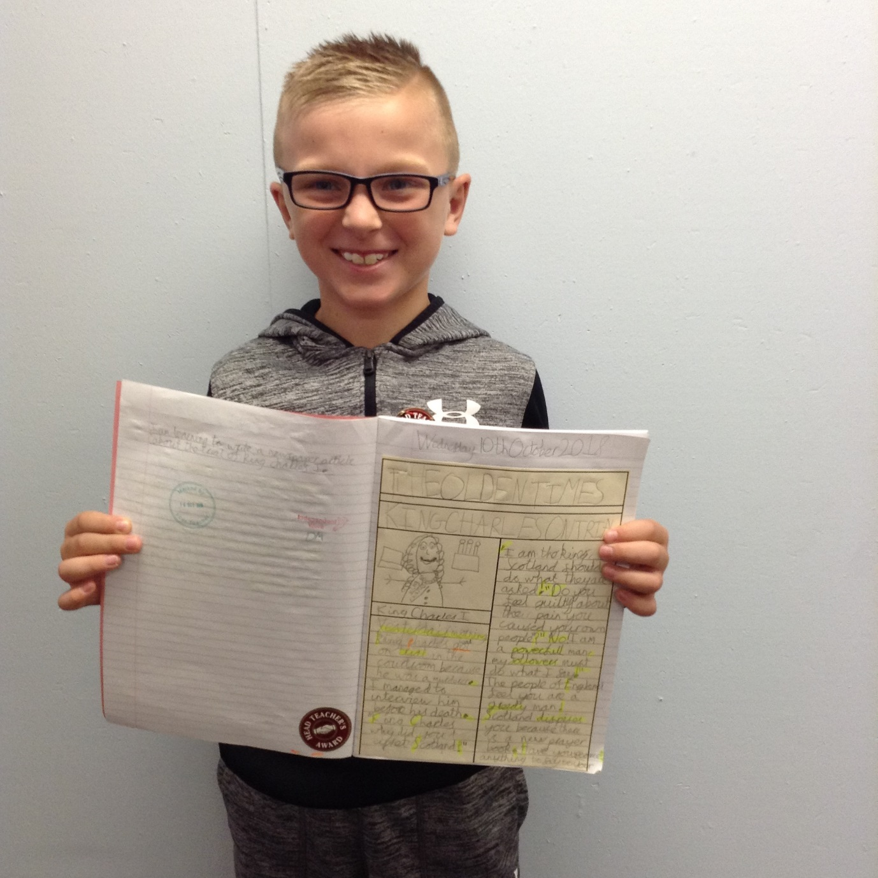
Zuzanna published a brilliant story in Y2!
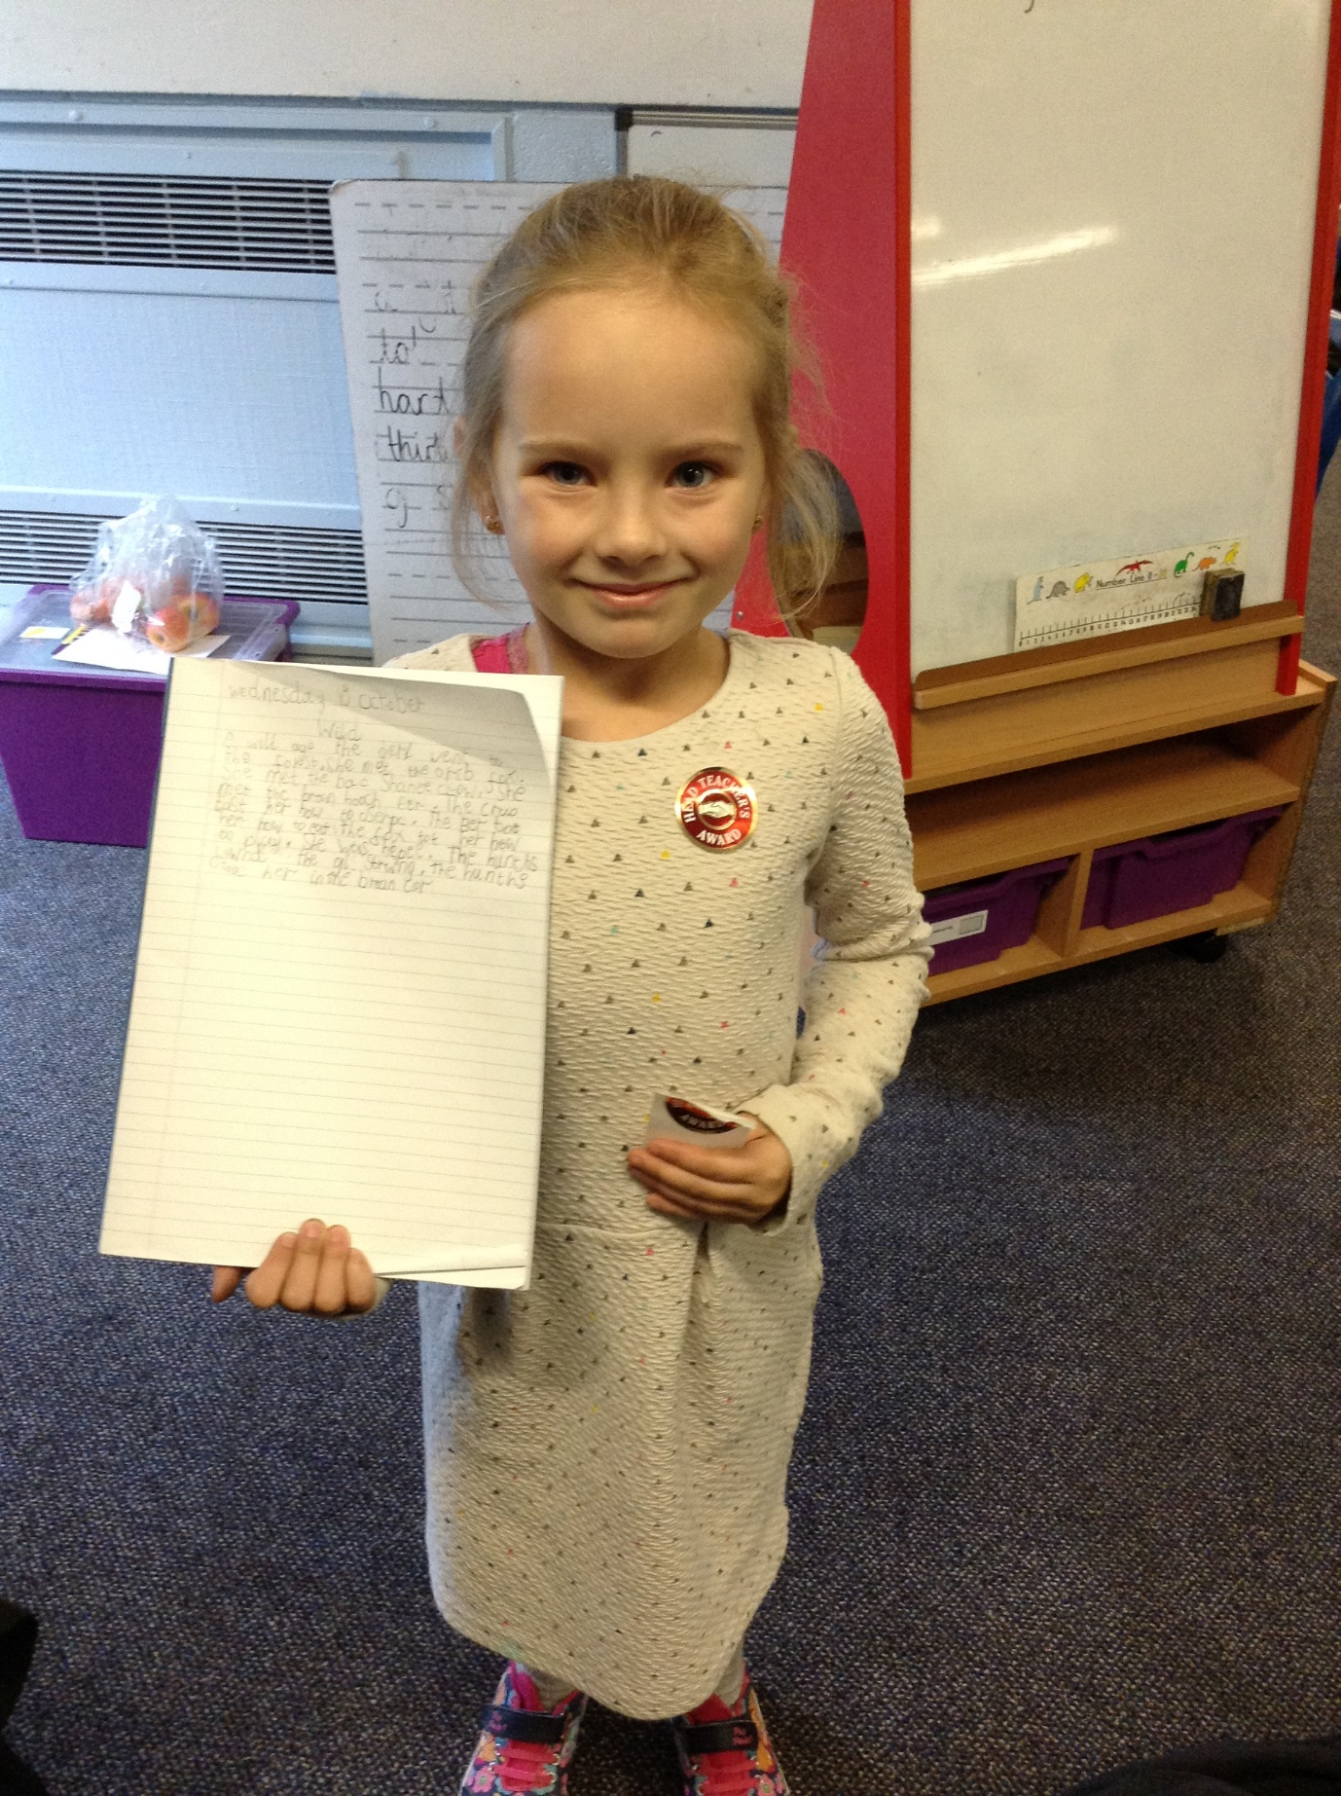

CJay in Y5 produced an amazing piece of homework.

Holiday Club will be open from Monday 15th October – Friday 26th October
Full day Price - £20
1/2 day Price- £11

Fun day:
Thursday 25th October will be a Halloween Fun Day. This will cost £25 per child for the full day from 7:45am – 5.45pm.
(No half day places on this day)
‘Fun Days’ include: Breakfast, dinner, tea and treats.

Events
We will b Saturday 16th June 2018

Y4 Children who have taken part in this year’s Sacramental Preparation Programme will make their First Holy Communion in a special Mass. The Mass starts at 10am in St Patrick’s Church.
This will be a wonderful celebration for school and parish.
e processing into church from school at 1:45. Mass will start at 2pm. We his being a great parish and school celebration of our patron saint’s day.

Community
In class this week
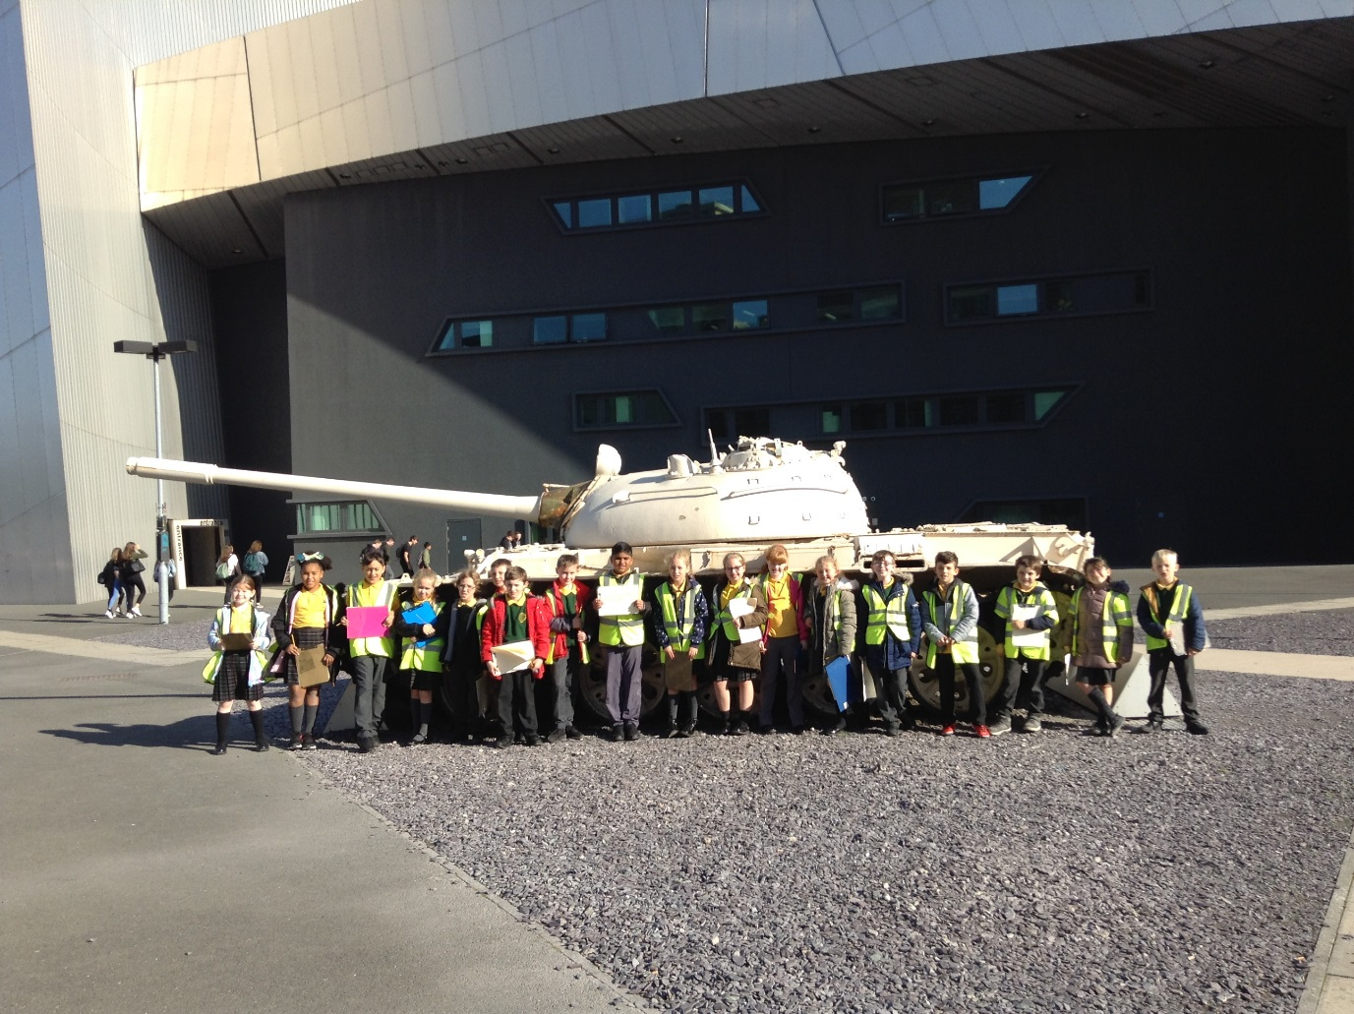
YY

25.10.2018- Holiday club Halloween theme day £25 per child

1.11.2018- Y3 children to attend church

5.11.2018- Class school photographs

7.11.2018- STEPS parent class in the training room (6 weeks)

8.11.2018- Y4 children to attend church

Year 5 have enjoyed their topic of World War 1 this half term and celebrated this with a visit to the Imperial War Museum in Manchester this week.

