
W
Newsletter - Week Beginning 24/9/2018
Dates, times and events are correct at the time of publication of this newsletter (though may be subject to some alterations or additions).
St. Patrick's
Catholic Primary School


Star of the week –
Week beginning 17.9.2018

Nursery | Emily Pendleton  Layla Unsworth  Alan Wu | RH | Henry Haugh
Nursery | Emily Pendleton  Layla Unsworth  Alan Wu | RML | Isaac Mather
Y1H | Conner Brown | Y4DM | Agnieszka Zalisz
Y1L | Jessica Bushell | Y4JM | Evie-Rose Mailey
Y2H | Alice Shawcross | Y5E | Dillan Clossick
Y2C | Leon Sharrock | Y5K | Jayden Dunsby
Y3M | Isabelle O’Neill | Y6G | McKenzie Coulton
Y3B | Daniela Anuze | Y6P | Zach Burchall

Top attended classes for the previous week 17.9.2018 | Class | Attendance %
1st | RH | 100%
2nd | Y3M & Y2C | 99.09%
3rd | Y1L | 99.05%
Whole school current academic year


97.02%

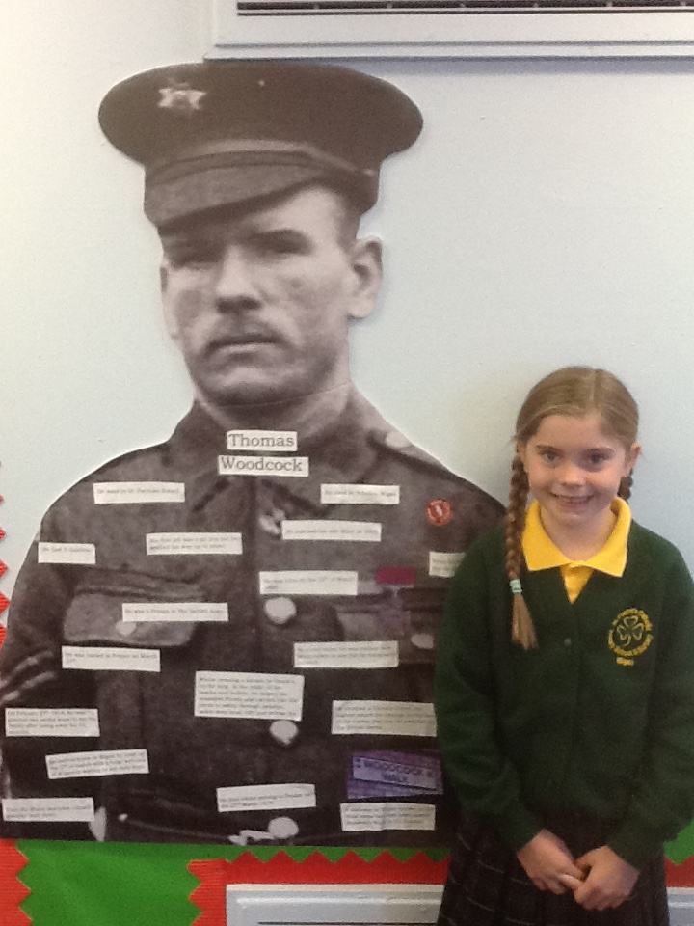
Headteacher Awards

Two children have achieved Headteacher awards this
week. Benjamin produced a super piece of artwork to
show his learning and understanding in RE, while
Lilyanna produced an amazing piece of
homework.
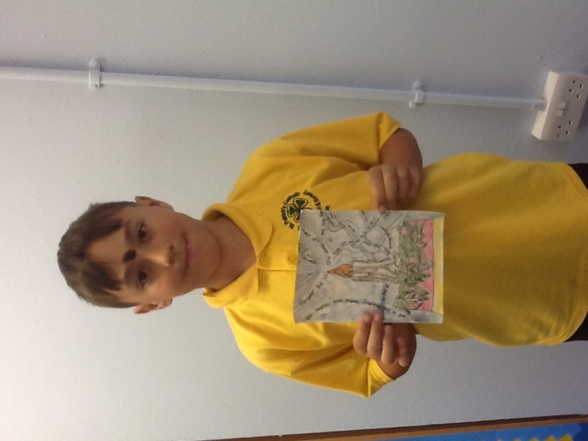

Events
We will b Saturday 16th June 2018

Y4 Children who have taken part in this year’s Sacramental Preparation Programme will make their First Holy Communion in a special Mass. The Mass starts at 10am in St Patrick’s Church.
This will be a wonderful celebration for school and parish.
e processing into church from school at 1:45. Mass will start at 2pm. We his being a great parish and school celebration of our patron saint’s day.

Community
In class this week
The R.E visitor noticed some excellent work in children’s books this week.
YY

- Y4 will be attending mass on Thursday 4th October.
- Reception start of year photograph Tuesday 2nd October.
- Parents afternoon Monday 8th October 2018 from 1:30pm
- Harvest celebration Friday 12th October, children to wear non uniform.

Harvest Celebration

During the week commencing 8th October 2018 as part of our Harvest celebration we will be collecting packaged food to donate to ‘The Brick’.

Friday 12th October Harvest celebration day. Children welcome to wear their own clothes.

