
W
Newsletter - Week Beginning 1/10/2018
Dates, times and events are correct at the time of publication of this newsletter (though may be subject to some alterations or additions).
St. Patrick's
Catholic Primary School


Star of the week –
Week beginning 24.9.2018

Nursery | Evie Wilde-Causey  Penelope Glaze  Sophie Whyte | RH | Evie Minshull
Nursery | Evie Wilde-Causey  Penelope Glaze  Sophie Whyte | RML | Patrick Unsworth
Y1H | Logan Baggaley | Y4DM | Agnieszka Zalisz
Y1L | Joshua Morris | Y4JM | Danny Stuart
Y2H | Alex Stroud | Y5E | Lilyanna Robinson
Y2C | Sophia Murphy | Y5K | Keite Krasauskyte
Y3M | Lily Hilton | Y6G | Kajus Jankauskas
Y3B | Katie Finney | Y6P | Scarlett Holcroft

Top attended classes for the previous week 24.9.2018 | Class | Attendance %
1st | Y2KC | 100%
2nd | Y6P | 99.09%
3rd | Y3RM | 98.18%
Whole school current academic year


96.54%

Headteacher Awards this week:

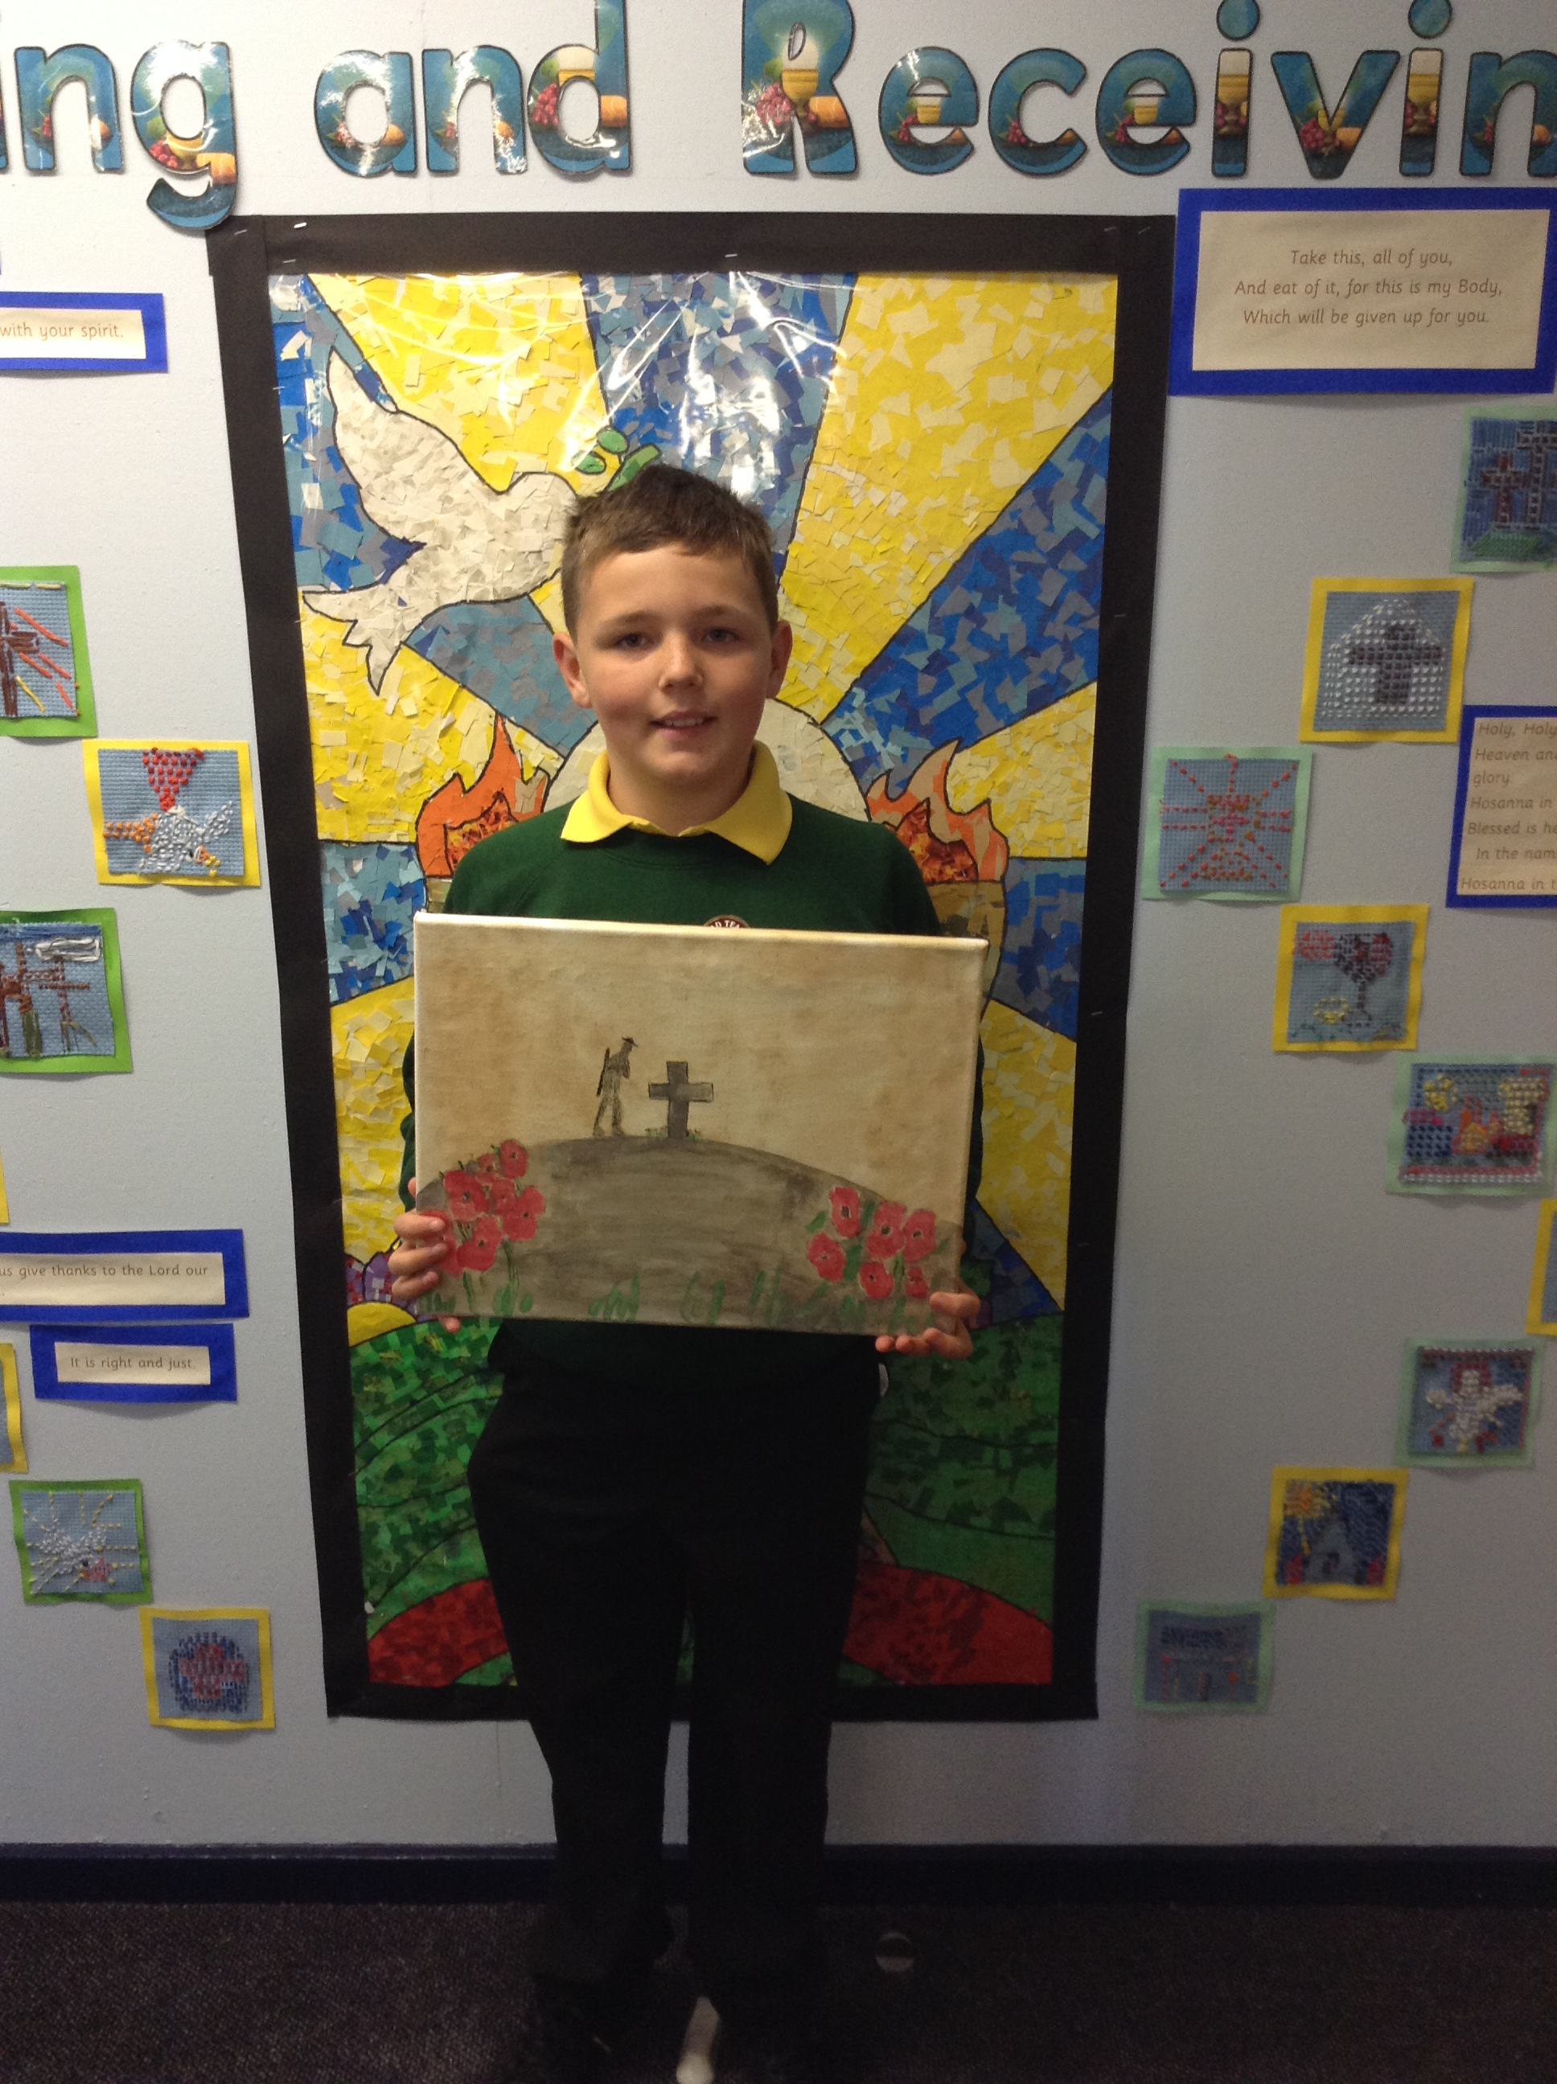
Logan produced a super story in Y4. 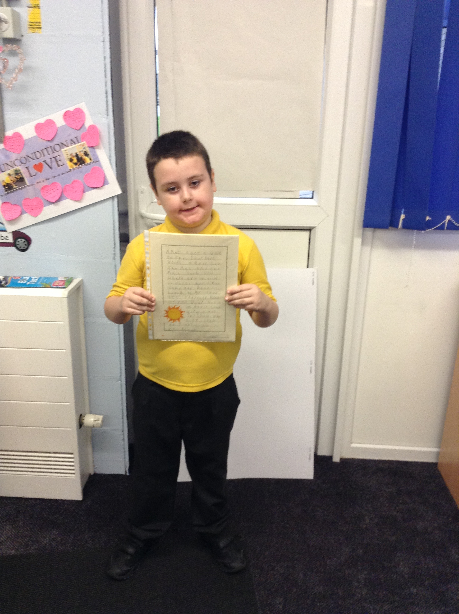

In Y1, Emile, Liam and Nina produced some fabulous RE writing.

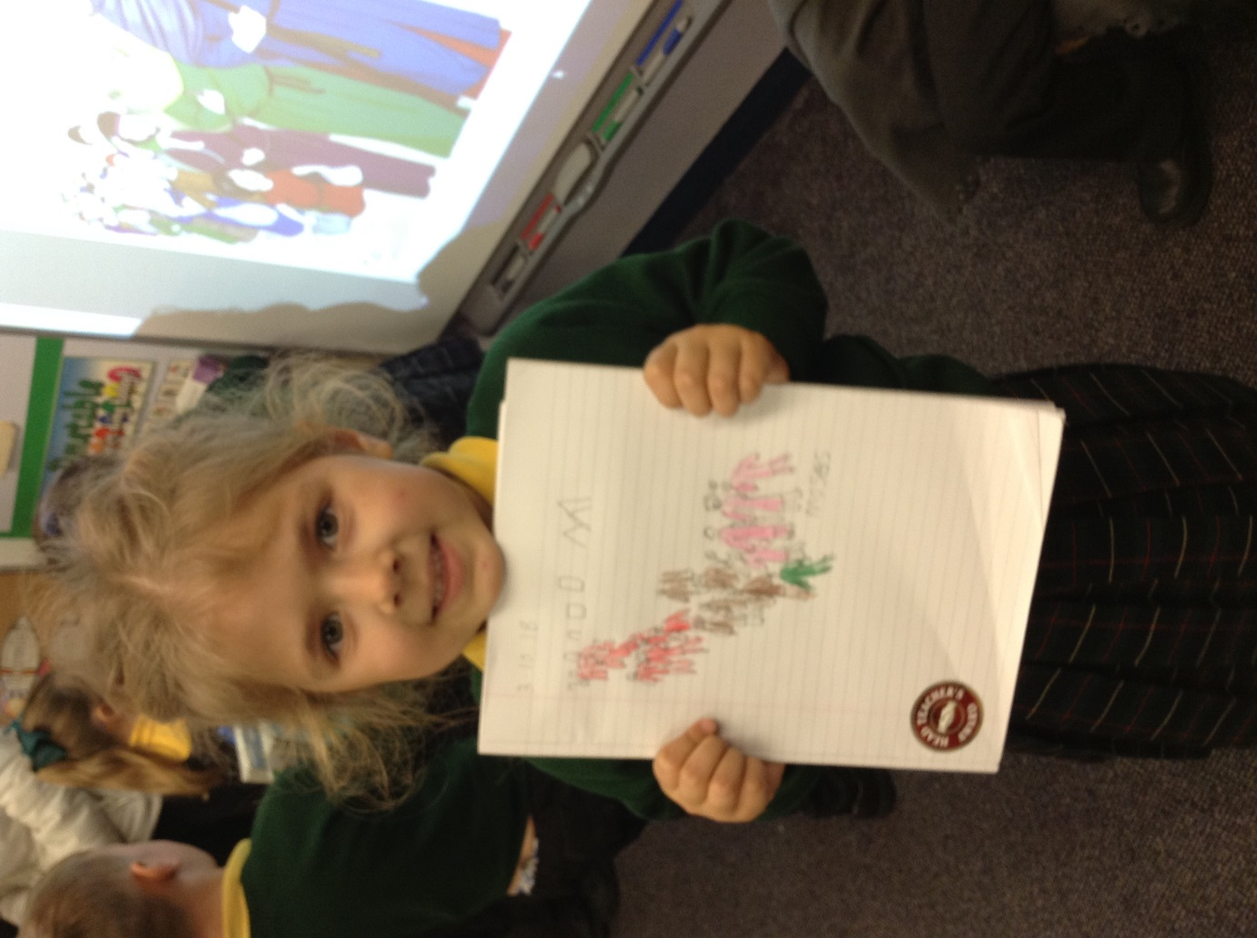
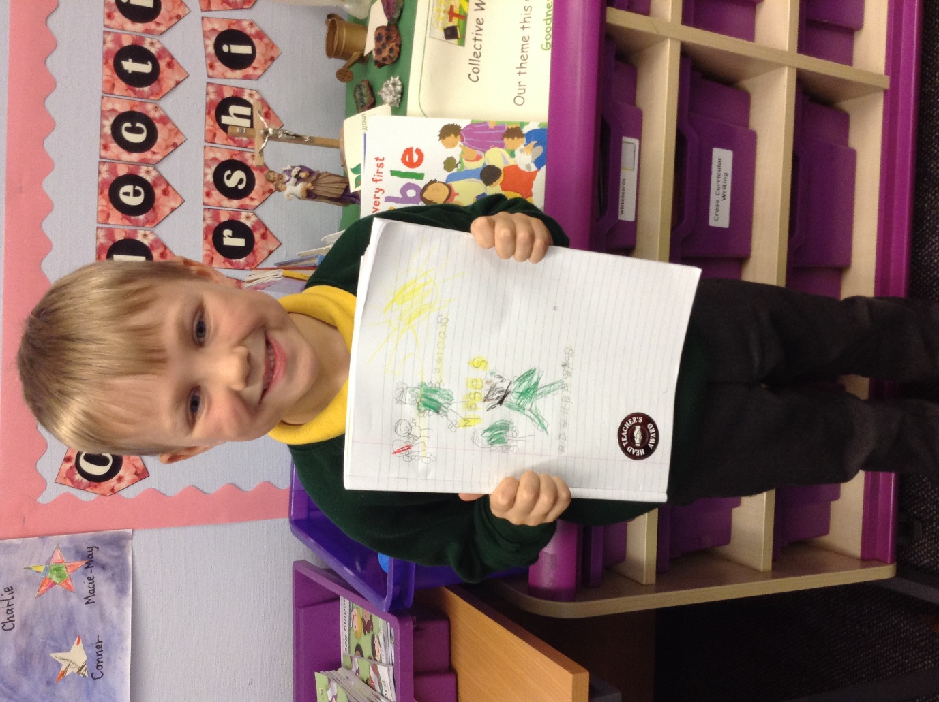
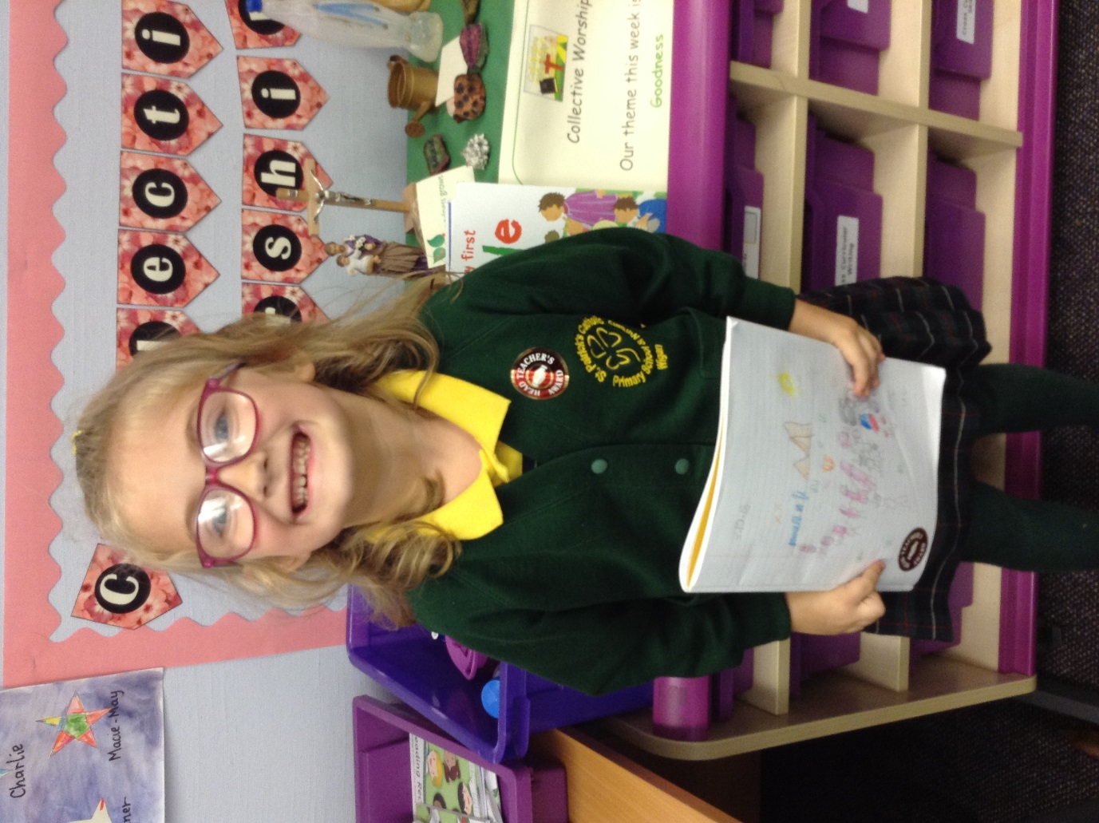
Isaac and Nathan in Y6 produced amazing pieces of homework.

Holiday Club will be open from Monday 15th October – Friday 26th October
Full day Price - £20
1/2 day Price- £11

Fun day:
Thursday 25th October will be a Halloween Fun Day. This will cost £25 per child for the full day from 7:45am – 5.45pm.
(No half day places on this day)
‘Fun Days’ include: Breakfast, dinner, tea and treats.

Events
We will b Saturday 16th June 2018

Y4 Children who have taken part in this year’s Sacramental Preparation Programme will make their First Holy Communion in a special Mass. The Mass starts at 10am in St Patrick’s Church.
This will be a wonderful celebration for school and parish.
e processing into church from school at 1:45. Mass will start at 2pm. We his being a great parish and school celebration of our patron saint’s day.

Community
In class this week
School has entered the Royal British Legion Memorial Garden Competition to commemorate 100 years since the end of the Great War. Year 6 have designed the garden, which will be situated near to the main entrance of school. Next Wednesday, work will begin on the construction of the garden and children will contribute throughout the day, creating art work, poetry and sculptures. Watch this space….

YY

- Y3 will be attending mass on Thursday 11th October.
- Parents afternoon Monday 8th October 2018 from 1:30pm
- Harvest celebration Friday 12th October, children to wear non uniform.

