
Newsletter - Week Beginning 4.12.2017
Dates, times and events are correct at the time of publication of this newsletter (though may be subject to some alterations or additions).
We are going to trial our new school newsletter until Christmas. We welcome your feedback. welcome.
St. Patrick's
Catholic Primary School


Star of the week - Week beginning 27.11.2017

Nursery | Louis Ryan | Y3B | Faith Sharples
Reception | Ryan Egington  Caitlyn Thompson  Ethan Wilde- Causey | Y4C | Archie Porter
Y1M | Christopher Massingham | Y4HW | Lillie Barnett
Y1D | Antoni Firlej | Y5L | Malakhi Atakora
Y2S | Florence McKenna | Y5HL | David Rzeznik
Y2M | Valentinas Kubilius | Y6AP | Ruo Wen Chen
Y3H | Mikayla McCoy | Y6JP | Brett Finch
Top attended classes for the previous week 27.11.2017 | Class | Attendance %
1st | Y3B | 100%
2nd | Y6JP Y6AP Y5HL | 98.18%
3rd | Y2S | 95.65%
Whole school current academic year


95.49%

Sports Update
Events
In class this week
Community
Congratulations to one of our former pupils Olivia Shaw-Wilkinson who has been recognised for her talents within taekwondo and has been selected to train with Great Britain in preparation for the European Championships.

Year 6
We have explored the meaning behind the Advent wreath and Advent calendar from CAFOD. We have created our own Advent calendar and explained how we can help Christians to prepare in expectation for the coming of the Messiah, Jesus.

Thank you for your support with our annual Christmas market.
We raised £502.71 for school fund!


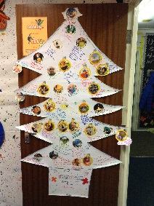
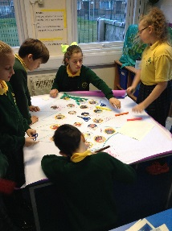
Monday 11th December 9:00-10:30 approx. coffee morning with mince pies and a general discussion about homework support.
Wednesday 13th December
Infant Performance -10am
Juniors Performance -1:30pm
Thursday 14th December
Juniors Performance -10am
Infants Performance -2pm
Friday 15th December Christmas Jumper Day

