
Newsletter - Week Beginning 27.11.2017
Dates, times and events are correct at the time of publication of this newsletter (though may be subject to some alterations or additions).
We are going to trial our new school newsletter until Christmas. We welcome your feedback. welcome.
St. Patrick's
Catholic Primary School


Star of the week - Week beginning 20.11.2017

Nursery | Lacey-Rae White | Y3B | Riley Anglesea
Reception | Bethany Rigby  Tony Tran  Connor Brown | Y4C | Connor O’Rouke
Y1M | Adriana Balode | Y4HW | Evan Borg
Y1D | Thomas Rumsey | Y5L | Romey Richardson
Y2S | Ruo-Jun Chen | Y5HL | Demi Sharrock
Y2M | Oliver Ndoukouo | Y6AP | Leland Taylor
Y3H | Daniella Kelly | Y6JP | Kyle Green
Top attended classes for the previous week 20.11.2017 | Class | Attendance %
1st | Y2M | 98.18%
2nd | Y6P & Y6JP | 96.36%
3rd | Y4C | 96.25%
Whole school current academic year


93.14%

Keeping Children Safe
Monday 4th Dec 9:00-10:30 approx. coffee morning with a workshop looking at supporting your children with Mathematics.

Friday 15th December Christmas Jumper Day

Events
In class this week

Community

A new section has been added onto the ‘Parents’ area of the school website called ‘Keeping Children Safe.’ In here you will find useful information to help keep children safe from all types of risks (stranger danger, e-safety, cyberbullying etc). As we receive updates and useful information from various agencies, we will add this to the website.
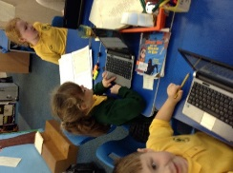
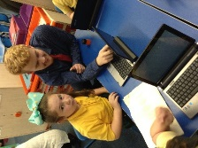
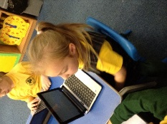
Thank you for your support with our annual Christmas market.
Watch this space next week to find out how much we raised!



Year 2
We have been researching different habitats in the UK and have been working on a PowerPoint presentation to showcase our knowledge.

