
Newsletter - Week Beginning 20.11.2017
Dates, times and events are correct at the time of publication of this newsletter and may be subject to some alterations or additions.
We are going to trial our new school newsletter until Christmas. Your feedback will be welcome.
St. Patrick's
Catholic Primary School


Star of the week - Week beginning 13.11.2017

Nursery | Bella McNicholas | Y3B | Agnes Zalisz
Reception | Jessica Bushell  Ava O’Hara-Howe  Grace Fitzpatrick | Y4C | Kai Thompson
Y1M | Bethany Henriksen | Y4HW | Keite Krasauskyte
Y1D | Alex Moseley | Y5L | Brooke Eccles
Y2S | Lily Hilton | Y5HL | Kia Sheridan
Y2M | Layton Dickinson | Y6AP | Sharna Rudd
Y3H | Danny Stuart | Y6JP | Kyle Green
Top attended classes for the previous week 13.11.2017 | Class | Attendance %
1st | Y2S | 99.57%
2nd | Y2M & Y6P | 97.73%
3rd | Y3B | 96.67%
Whole school current academic year


94.29%


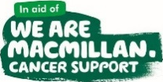
Sporting Achievements
Monday 27th- 9:00- coffee morning with a workshop looking at supporting your children with reading.
Friday 1stDec– 8:30-11:30- Christmas market in school.

Events
In class this week

Community


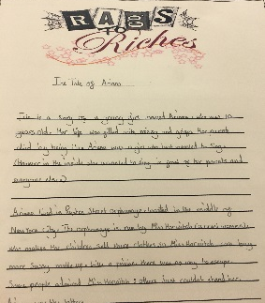
Well done to the Y6 children who took part in the cross country challenge. Approximately 250 children took part in each race. Jessica Rigby came 64th in her race and Joshua Connolly came 86th in his. This is an excellent achievement.
Thank you for all your support with our recent charity work.

The Macmillan coffee morning raised £243.39.

The non-uniform ‘dress spotty’ day for Children in Need raised £263.00.

This week year 5 have been publishing their ‘Rags to Riches’ stories. The children have worked very hard on these and we are all so proud of the end result!
Read a sample on the school website.

