
Newsletter - Week Beginning 18.12.2017
Dates, times and events are correct at the time of publication of this newsletter (though may be subject to some alterations or additions).
We are going to trial our new school newsletter until Christmas. We welcome your feedback. welcome.
St. Patrick's
Catholic Primary School


Star of the week –
Week beginning 18.12.2017

Nursery | Erin Hopper | Y3B | Ruby Wallis
Reception | Nikolas Karak  Mia Aaron  Nina Duda | Y4C | Harley Whalley
Y1M | Logan Stokes | Y4HW | Jayden Dunsby
Y1D | Jakub Zalisz | Y5L | Harry Meadows
Y2S | Filip Handke | Y5HL | Kajus Jankauskas
Y2M | Jessica Liptrot | Y6AP | Summer Gallear
Y3H | Alex Hobden | Y6JP | Conor Foley
Top attended classes for the previous week 11.12.2017 | Class | Attendance %
1st | Y2S | 98.11%
2nd | Y6P | 96.74%
3rd | Y5HL | 96.66%
Whole school current academic year


95.22%

Sporting Achievement
Ella Unsworth took part in a gymnastics competition at Robin Park. She received two medals; one for coming fourth and one for taking part. Well done Ella!
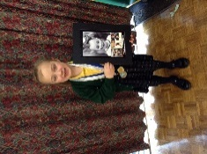
Events
Community

In class this week

Christmas Fun!

Children fully enjoyed the visit to Southport Theatre!

A big thank you to Joe Charnock who has kindly donated a variety of trainers and rugby boots to school.
The children, staff and governors would like to take this opportunity to wish you all a happy and peaceful Christmas and we look forward to seeing you all in the New Year.
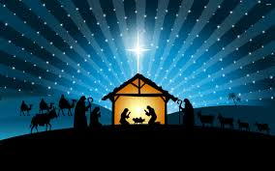


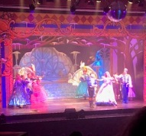
Christmas Mass Times
Saint Patrick’s Catholic Church
Christmas Eve – 7pm
Christmas Day – 9.30am
Holiday Club are open on Tuesday 2nd January 2018. Cost: £19 full day; £10 half day. Please see Miss Govan or Mrs Glaze for further details (01942 776710).
Return to school – Wednesday 3rd January 2018.

