
Newsletter - Week Beginning 11.12.2017
Dates, times and events are correct at the time of publication of this newsletter (though may be subject to some alterations or additions).
We are going to trial our new school newsletter until Christmas. We welcome your feedback. welcome.
St. Patrick's
Catholic Primary School


Star of the week –
Week beginning 4.12.2017

Nursery | Erin Hopper | Y3B | Ruby Wallis
Reception | Ryan Egington  Caitlyn Thompson  Ethan Wilde- Causey | Y4C | Lucy Seddon
Y1M | Lexi Bretherton | Y4HW | Lauren Simm
Y1D | Maisie McDonough | Y5L | Harry Meadows
Y2S | Charlie Reeves | Y5HL | Olivia Richardson
Y2M | Alfie Chen | Y6AP | Abigail Massingham
Y3H | Mackenzie Halpin | Y6JP | Hannah-Rose Hesketh
Top attended classes for the previous week 4.12.2017 | Class | Attendance %
1st | Y4HW | 99%
2nd | Y1D | 98.1%
3rd | Y5HL | 97.73%
Whole school current academic year

95.12%

Sports Update
Congratulations to Harry Meadows (Y5) who has won the 2017 Helsinki Open Wrestling competition in the age 9-10 class! Over 200 competitors entered from Finland, Sweden, Russia, Latvia and England.
Community

In class this week
Events
Christmas Mass Times
Saint Patrick’s Catholic Church
Christmas Eve –7pm
Christmas Day –9:30am

Year 4
In Year 4 we have been labelling human and physical features on an aerial map of our local area.

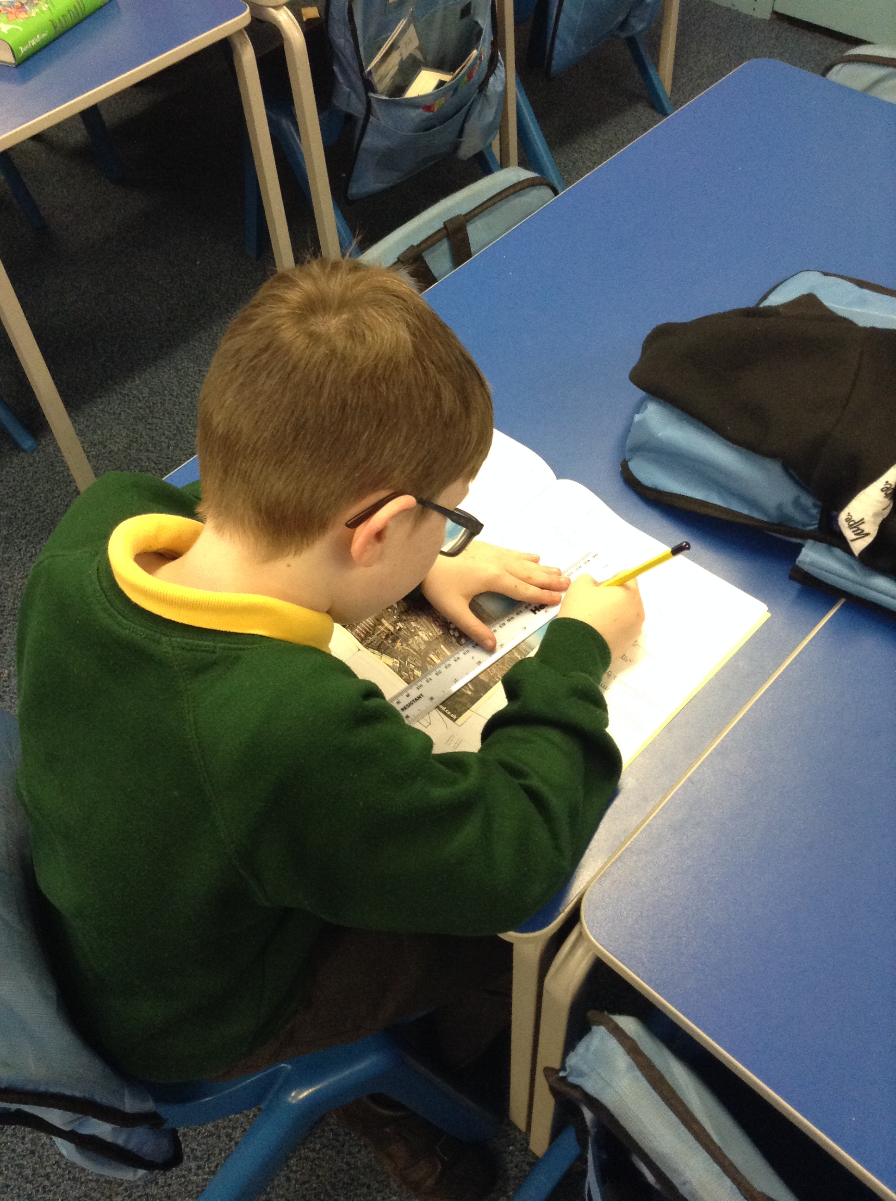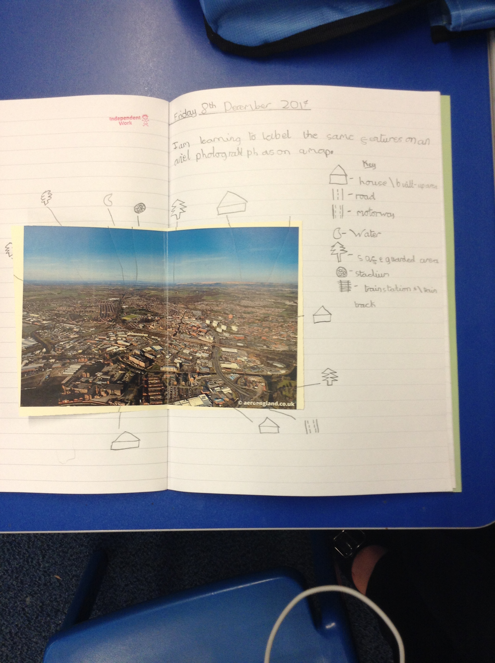
Christmas Disco- Monday 18th December - Reception & Year 1 – Disco with party games 4:15-5:15pm
Year 2-Year 6 Disco -5:30pm-7:00pm
Christmas Events- Tuesday 19th December – Y2-Y6 Christmas panto at Southport. Nursery – Y1 Christmas party with magician in the afternoon.
Breakfast with Santa- Wednesday 20th December – Nursery, Reception and Y1 - 9-11am
Carol Service - Wednesday 20th December - Starts at 1pm, doors open from 12:45
Holiday Club are open on Tuesday 2nd January 2018. Cost: £19 full day; £10 half day. Please see Miss Govan or Mrs Glaze for further details (01942 776710)

