


St. Patrick's
Catholic Primary School

‘We arise today to learn, love and grow through Jesus.’
Newsletter - Week Beginning 14.10.2024
Dates, times and events are correct at the time of publication of this newsletter
(though may be subject to some alterations or additions).
Top attended classes for the previous week 7.10.2024 |   Class | Attendance %
Gold | Y5 | 98.94%
Silver | Y4 | 97.78%
Bronze | Y3 | 96.44%

Whole school current academic year
95.17%

Star of the Week
Week Beginning
7.10.2024
Nursery | Paddy Boyd | Reception | Luca Baicu
Nursery | Florence Clarke | Reception | Millie Smethurst
Year 1 | Lucas Tarbuck | Year 4 | Amber-Rose Samuel
Year 1 | Reggie Kane | Year 4 | Emmie-Leigh Tennant
Year 2 | Evie Price | Year 5 | Reece Ashurst
Year 2 | Owen Rigby | Year 5 | Thomas Breheny
Year 3 | Alex O’Reilly | Year 6 | Emily Ellison
Year 3 | Theo Howe | Year 6 | Annliya Shelly

‘

A huge well done to Jamie (Y4) for filling his ‘Going for Gold’ chart. Jamie chose a voucher out of the vending machine for his prize. Well done, Jamie!

AFTER HALF TERM: THE NEXT TWO WEEKS…
Week Beginning | Maths Matters (Monday) |  | Stay and Read  (Tuesday) |  | Stay and Pray  (Wednesday) |  |  | Attending 9:15am Mass (Thursday)
4.11.24 | Year 4 |  | Year 6 |  | Reception |  |  | Year 3
11.11.24 |  | Year 3 |  | Year 5 |  | Year 6 | Year 6
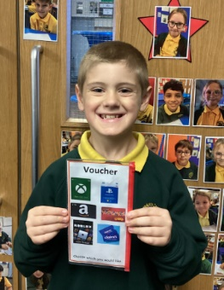

In Class This Week: Year 5

This week, we have been creating Remembrance Themed Art in the style of Annie O’Brien Gonzales. We enjoyed using a range of materials, including acrylic paints.

Events
17/9/24 - Dogs Trust in School;

30/9/24 – CAFOD in School;

7/10/24 – Black History Month Workshops in School;

10/10/24 – Hello Yellow Day for Mental Health Awareness;

14/10/24 – Y6 Retreat Day at Lowe House, St Helens

15/10/24 – Photograph Day
e 16th June 2018

Y4 Children who have taken part in this year’s Sacramental Preparation Programme will make their First Holy Communion in a special Mass. The Mass starts at 10am in St Patrick’s Church.
This will be a wonderful celebration for school and parish.
e processing into church from school at 1:45. Mass will start at 2pm. We his being a great parish and school celebration of our patron saint’s day.

St Patrick’s Church

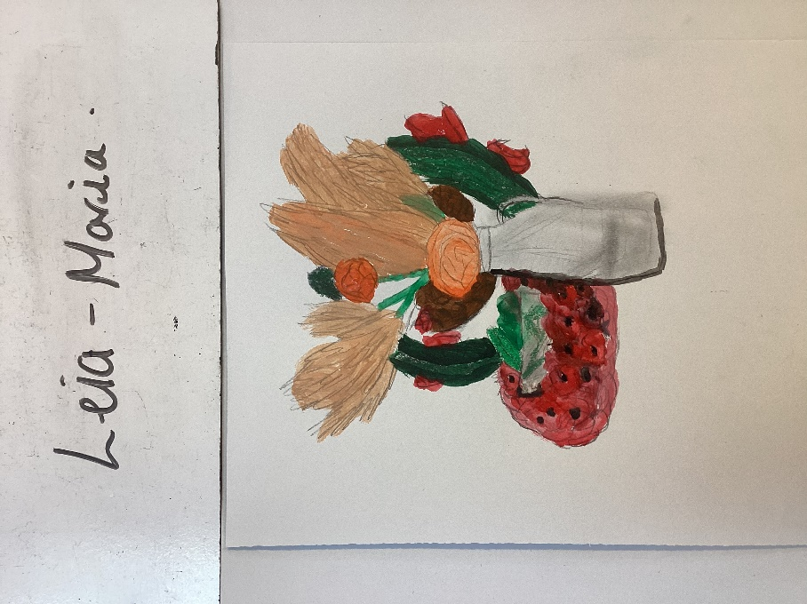
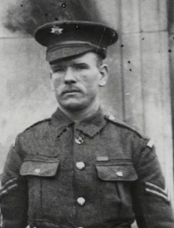
4/11/24 – Y4 visiting Imperial War Museum North

11/11/24 – Y2 visiting Wigan Heritage Centre to learn about Thomas Woodcock VC.

11/11/24 Y5 and Y6 Act of Remembrance with Fr Hugh.

14/11/24 – Deadline for Operation Christmas Child Shoebox Appeal.

18/11/24 – British Parliament Week

25/11/24 – RockKidz in School.

An Informal Talk on Thomas Woodcock VC
In the Lappin Room, on Monday 4th November, at 7pm. All are welcome. Donations towards Refreshments will be given to the Royal British Legion.

