


St. Patrick's
Catholic Primary School

‘We arise today to learn, love and grow through Jesus.’
Newsletter - Week Beginning 7.10.2024
Dates, times and events are correct at the time of publication of this newsletter
(though may be subject to some alterations or additions).
Top attended classes for the previous week 30.9.2024 |   Class | Attendance %
Gold | Y6 | 98.37%
Silver | Y2 | 98.09%
Bronze | Y4 | 97.56%

Whole school current academic year
95.3%

Star of the Week
Week Beginning
30.9.2024
Nursery | Emily Newton | Reception | Willow Dunn
Nursery | Tommy Eccleston | Reception | Theodora McElchar
Year 1 | Jacob Cockle | Year 4 | Ellie Wilkieson
Year 1 | Bella Nicorici | Year 4 | Mason Cain
Year 2 | Isaac Schofield | Year 5 | Freddie Bannister
Year 2 | Carmen Wills | Year 5 | Leia-Maria Obada-Vasiliu
Year 3 | Ava-Rose Ramsdale | Year 6 | Emilee Dean
Year 3 | Mia Cooper | Year 6 | Henry Haugh

Celebrations
A huge well done to Archie, Ethan and Louie (all Y4) this week for completing their ‘Going for Gold’ charts.
Celebrations

‘

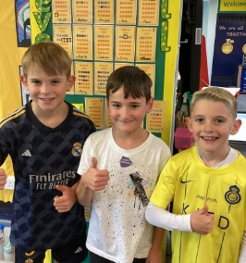

THE NEXT TWO WEEKS…
Week Beginning | Maths Matters (Monday) | Stay and Read  (Tuesday) | Stay and Pray  (Wednesday) | Attending 9:15am Mass (Thursday)
14.10.24 | Year 6 | Reception | Year 1 | Year 4
2 Week Half Term. Return to School on Monday 4th November.

In Class This Week: Year 4

This week, the children enjoyed participating in a workshop ran by Big Foot Education to celebrate Black History month. The children enjoyed role play and hot seating activities.

Events
17/9/24 - Dogs Trust in School;

30/9/24 – CAFOD in School;

7/10/24 – Black History Month Workshops in School;

10/10/24 – Hello Yellow Day for Mental Health Awareness;

14/10/24 – Y6 Retreat Day at Lowe House, St Helens

15/10/24 – Photograph Day
e 16th June 2018

Y4 Children who have taken part in this year’s Sacramental Preparation Programme will make their First Holy Communion in a special Mass. The Mass starts at 10am in St Patrick’s Church.
This will be a wonderful celebration for school and parish.
e processing into church from school at 1:45. Mass will start at 2pm. We his being a great parish and school celebration of our patron saint’s day.

St Patrick’s Church

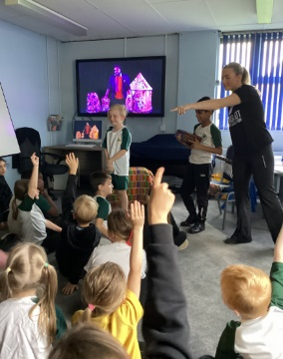
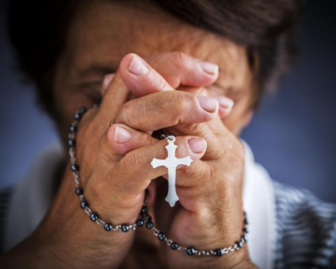
14/10/24 – Y6 Retreat Day at Lowe House, St Helens

15/10/24 – Photograph Day

16/10/24 – Flu Immunisation (please return the form as soon as possible)

4/11/24 – Y4 visiting Imperial War Museum North

11/11/24 – Y2 visiting Wigan Heritage Centre to learn about Thomas Woodcock VC.

17/11/24 – Deadline for Operation Christmas Child Shoebox Appeal.

During October, the Holy Rosary will be prayed in St Patrick’s Church on Mondays at 12:15pm. All are welcome.

