


St. Patrick's
Catholic Primary School

‘We arise today to learn, love and grow through Jesus.’
Newsletter - Week Beginning 30.9.2024
Dates, times and events are correct at the time of publication of this newsletter
(though may be subject to some alterations or additions).
Top attended classes for the previous week 23.9.2024 |   Class | Attendance %
Gold | Y5 | 98.72%
Silver | Y3&Y4 | 97.33%
Bronze | Y2 | 96.6%

Whole school current academic year
94.63%

Star of the Week
Week Beginning
23.9.2024
Nursery | Autumn Aspey | Reception | Milana Mitickina
Nursery | Jayden Idam Aluu | Reception | Max Perkins
Year 1 | Jamin Jacob | Year 4 | Louie Robinson
Year 1 | Neriah Idam Aluu | Year 4 | Oliver Araujo
Year 2 | Aria Ryan | Year 5 | Harvey Hockey
Year 2 | Oceana Ward | Year 5 | Layla Jamieson
Year 3 | Anastasia Ward | Year 6 | Louis Ryan
Year 3 | Maria Ondo Belloso | Year 6 | Aylin Omian

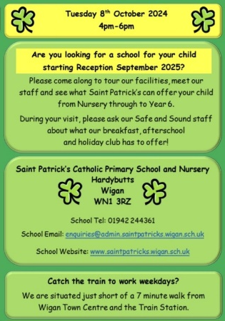

‘

THE NEXT TWO WEEKS…
Week Beginning | Maths Matters (Monday) | Stay and Read  (Tuesday) | Stay and Pray  (Wednesday) | Attending 9:15am Mass (Thursday)
7.10.24 | Year 5 | Year 1 | Year 2 | Year 6
14.10.24 | Year 6 | Reception | Year 1 | Year 4

This week, Year 3 have been learning all about light and shadows in Science. We carried out an experiment to explore creating shadows with the torches.

St Patrick’s Church
In Class This Week: Year 3

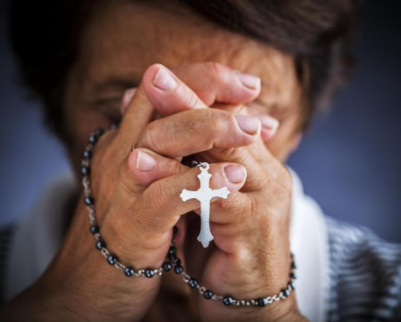
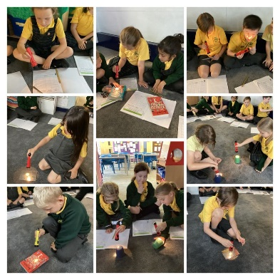

17/9/24 - Dogs Trust in School;

30/9/24 – CAFOD in School;

7/10/24 – Black History Month Workshops in School;

10/10/24 – Hello Yellow Day for Mental Health Awareness;

14/10/24 – Y6 Retreat Day at Lowe House, St Helens

15/10/24 – Photograph Day
e 16th June 2018

Y4 Children who have taken part in this year’s Sacramental Preparation Programme will make their First Holy Communion in a special Mass. The Mass starts at 10am in St Patrick’s Church.
This will be a wonderful celebration for school and parish.
e processing into church from school at 1:45. Mass will start at 2pm. We his being a great parish and school celebration of our patron saint’s day.

Events
7/10/24 – Black History Month Workshops in School;

10/10/24 – Hello Yellow Day for Mental Health Awareness;

14/10/24 – Y6 Retreat Day at Lowe House, St Helens

15/10/24 – Photograph Day

16/10/24 – Flu Immunisation (please return the form as soon as possible)

During October, the Holy Rosary will be prayed in St Patrick’s Church on Mondays at 12:15pm. All are welcome.

