


St. Patrick's
Catholic Primary School

‘We arise today to learn, love and grow through Jesus.’
Newsletter - Week Beginning 23.9.2024
Dates, times and events are correct at the time of publication of this newsletter
(though may be subject to some alterations or additions).
Top attended classes for the previous week 16.9.2024 |   Class | Attendance %
Gold | Y3 | 97.33%
Silver | Y5 | 97.23%
Bronze | Y4 | 96.22%

Whole school current academic year
94.6%

Star of the Week
Week Beginning
16.9.2024
Nursery | Alice Sawers | Reception | Wateen Nasir
Nursery | Olive Atkins | Reception | Alex Reyes-Laithwaite
Year 1 | Parizay Ahmed | Year 4 | Abdu Rooby
Year 1 | Ruby Bullough | Year 4 | Zahran Ahmed
Year 2 | Mason Stokes | Year 5 | Owen O’Reilly
Year 2 | Alice Nicorici | Year 5 | Aaliyah Youssef
Year 3 | Dawid Swidrak | Year 6 | Denise Nweke
Year 3 | Eden McDonough | Year 6 | Erin Hopper

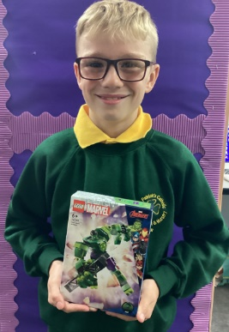
A huge well done to George for completing his Going for Gold card for going above and beyond in his learning and the classroom. George couldn’t wait to go to the vending machine and choose his prize!

THE NEXT TWO WEEKS…
Week Beginning | Maths Matters (Monday) | Stay and Read  (Tuesday) | Stay and Pray  (Wednesday) | Attending 9:15am Mass (Thursday)
30.9.24 | Year 1 | Year 2 | Year 3 | Year 5
7.10.24 | Year 5 | Year 1 | Year 2 | Year 6

In Class This Week: Year 2

This week, in Science we have been learning about everyday materials. We have sorted them into different categories such as rigid and flexible, smooth and rough and manmade and natural.

Events
17/9/24 - Dogs Trust in School;

30/9/24 – CAFOD in School;

7/10/24 – Black History Month Workshops in School;

10/10/24 – Hello Yellow Day for Mental Health Awareness;

14/10/24 – Y6 Retreat Day at Lowe House, St Helens

15/10/24 – Photograph Day
e 16th June 2018

Y4 Children who have taken part in this year’s Sacramental Preparation Programme will make their First Holy Communion in a special Mass. The Mass starts at 10am in St Patrick’s Church.
This will be a wonderful celebration for school and parish.
e processing into church from school at 1:45. Mass will start at 2pm. We his being a great parish and school celebration of our patron saint’s day.

St Patrick’s Church

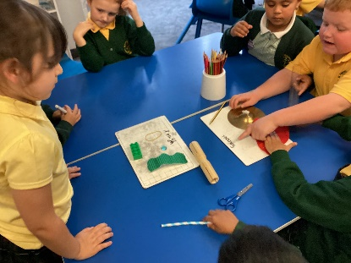

30/9/24 – CAFOD in School;

7/10/24 – Black History Month Workshops in School;

10/10/24 – Hello Yellow Day for Mental Health Awareness;

14/10/24 – Y6 Retreat Day at Lowe House, St Helens

15/10/24 – Photograph Day



We are purchasing new Mass Books for the back of the Church. If you would like to sponsor a Mass Book in memory of a loved one, please place £20 (the cost of one individual book) in an envelope – alongside the person’s name – and hand to Mr Marshall or at Church directly. Names will be scribed on the inside front cover.

