


St. Patrick's
Catholic Primary School

‘We arise today to learn, love and grow through Jesus.’
Newsletter - Week Beginning 16.9.2024
Dates, times and events are correct at the time of publication of this newsletter
(though may be subject to some alterations or additions).
Top attended classes for the previous week 9.9.2024 |   Class | Attendance %
Gold | Y3 | 97.78%
Silver | Y5 & Y4 | 96.38%
Bronze | Y6 | 94.19%

Whole school current academic year
94.2%

Star of the Week
Week Beginning
9.9.2024
Nursery | Scarlett McMullen | Reception | Brodie Simm
Nursery | Violet McMullen | Reception | Khalid Olayiwola
Year 1 | Ray Doyle | Year 4 | Ruby Moran
Year 1 | Nathaniel Adebisi | Year 4 | Kevinas Barcaitis
Year 2 | John Ward | Year 5 | Callum Gore
Year 2 | Kamil Handke | Year 5 | Teresa Ward
Year 3 | Amelia Unsworth | Year 6 | Noah Ashworth
Year 3 | Leona Jones | Year 6 | Mamoon Ahmed

Alice and Emily in Nursery, have earned a Headteacher’s Award for writing their names independently. Well done, amazing writing!

‘

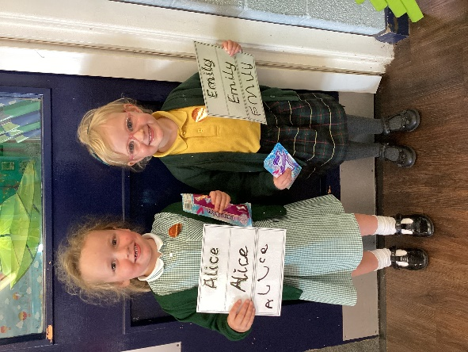


All families are invited to the MacMillan Cancer Support Coffee Morning, in the Lappin Room at Church, on Sunday 22nd September after the 9:15am Mass.

In Class This Week: Year 1

This week, Year 1 have had a visit from Dogs Trust. We learnt how we can be a dog’s best friend and how to be safe around dogs we meet out and about.

Events
17/9/24 - Dogs Trust in School;

30/9/24 – CAFOD in School;

7/10/24 – Black History Month Workshops in School;

10/10/24 – Hello Yellow Day for Mental Health Awareness;

14/10/24 – Y6 Retreat Day at Lowe House, St Helens

15/10/24 – Photograph Day
e 16th June 2018

Y4 Children who have taken part in this year’s Sacramental Preparation Programme will make their First Holy Communion in a special Mass. The Mass starts at 10am in St Patrick’s Church.
This will be a wonderful celebration for school and parish.
e processing into church from school at 1:45. Mass will start at 2pm. We his being a great parish and school celebration of our patron saint’s day.

St Patrick’s Church

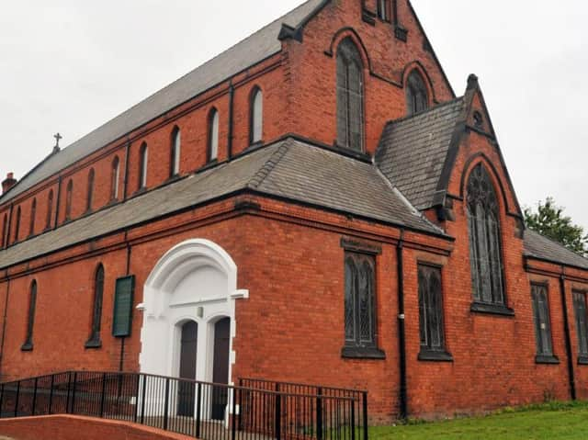

30/9/24 – CAFOD in School;

7/10/24 – Black History Month Workshops in School;

10/10/24 – Hello Yellow Day for Mental Health Awareness;

14/10/24 – Y6 Retreat Day at Lowe House, St Helens

15/10/24 – Photograph Day

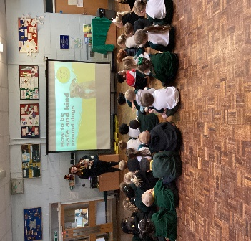

Mass Times:
Sunday – 9:15am
Tuesday – 7:30pm
Wednesday – 7:30pm
Thursday – 9:15am (School Mass)
Friday – 7:30pm
Saturday – 9:15am

