


St. Patrick's
Catholic Primary School

‘We arise today to learn, love and grow through Jesus.’
Newsletter - Week Beginning 9.9.2024
Dates, times and events are correct at the time of publication of this newsletter
(though may be subject to some alterations or additions).
Top attended classes for the previous week 2.9.2024 |   Year Group | Attendance %
Gold | Reception | 98.6%
Silver | Year 4 | 96%
Bronze | Year 2 | 95.11%

Whole school current academic year
93.08%

Star of the Week
Week Beginning
2.9.2024
Nursery | Kamsi Omokwe | Reception | Wiktoria Chudy
Nursery | Lottie Johnson | Reception | Iris Kamau
Year 1 | Arjun Jyothish | Year 4 | Harry Eccles
Year 1 | Leon Jarvis | Year 4 | Adriel Maseya
Year 2 | Jack Aaron | Year 5 | William Lawson
Year 2 | Charlotte Ready | Year 5 | Tommy Tennant
Year 3 | Olly Holland | Year 6 | Cain Collier
Year 3 | Nathan Barry | Year 6 | Owen Jones

‘
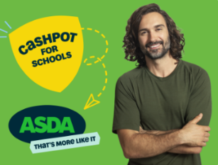


All families are invited to the MacMillan Cancer Support Coffee Morning, in the Lappin Room at Church, on Sunday 22nd September after the 9:15am Mass.

Please support us by choosing our school through the Asda Rewards app.

In Class This Week: Reception

Events
17/9/24 - Dogs Trust in School;

30/9/24 – CAFOD in School;

7/10/24 – Black History Month Workshops in School;

10/10/24 – Hello Yellow Day for Mental Health Awareness;

14/10/24 – Y6 Retreat Day at Lowe House, St Helens

15/10/24 – Photograph Day
e 16th June 2018

Y4 Children who have taken part in this year’s Sacramental Preparation Programme will make their First Holy Communion in a special Mass. The Mass starts at 10am in St Patrick’s Church.
This will be a wonderful celebration for school and parish.
e processing into church from school at 1:45. Mass will start at 2pm. We his being a great parish and school celebration of our patron saint’s day.

St Patrick’s Church

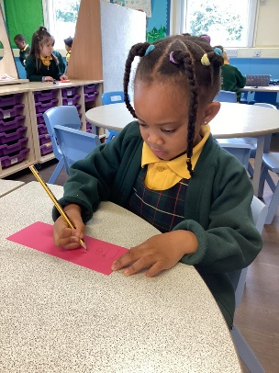
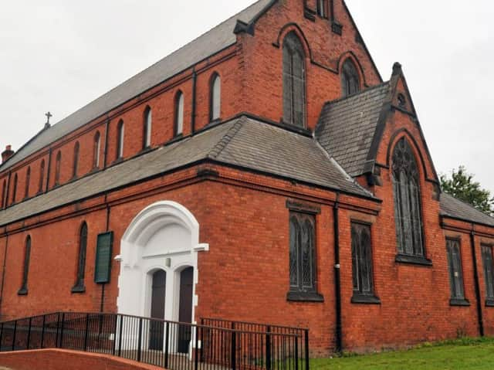
17/9/24 - Dogs Trust in School;

30/9/24 – CAFOD in School;

7/10/24 – Black History Month Workshops in School;

10/10/24 – Hello Yellow Day for Mental Health Awareness;

14/10/24 – Y6 Retreat Day at Lowe House, St Helens

15/10/24 – Photograph Day

A warm invitation is extended to all of our families to join the Parish for Sunday Mass.

Mass is celebrated at 9:15am and all families are most welcome.
This week in Reception, we have been thinking about how our names are unique and special to us. We have been practicing writing our own names.

