

‘We arise today to learn, love and grow through Jesus.’
St. Patrick's
Catholic Primary School

Newsletter - Week Beginning 2/9/2024
Dates, times and events are correct at the time of publication of this newsletter (though may be subject to some alterations or additions).


Welcome Back!

A very warm welcome back to everybody for the start of this new academic year. We look forward to the year ahead, working together to support all our children at St. Patrick’s.
Mrs Hobden

.

Stay and Pray Autumn 1
Wednesdays 9:05am-9:15am.
15.9.2023- Year 6
22.9.2023-Year 5
29.9.2023- Year 4
6.10.2023- Year 3
13.10.2023- Year 2
20.10.2023 Year 1
10.11.2023- Reception

Start of Academic Year Mass
We invite all parents, carers and families to join us in Church on Thursday, 12th September, at 9:30am for our Start of Academic Year Mass.
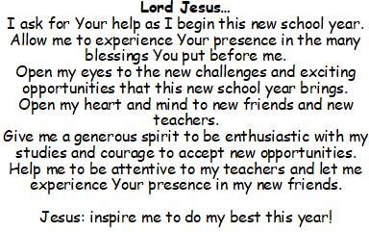
Stay and Read Autumn 1
Tuesdays 9:05am-9:25am.

10th September – Year 5
17th September – Year 4
24th September – Year 3
1st October – Year 2
8th October – Year 1
15th October – Reception

A Start of Academic Year Prayer…




YY

St Patrick’s Church

In class this week
Nursery
We have been learning all about ourselves and making lots of new friends.

Events
2018

Y4 Children who have taken part in this year’s Sacramental Preparation Programme will make their First Holy Communion in a special Mass. The Mass starts at 10am in St Patrick’s Church.
This will be a wonderful celebration for school and parish.
church from school at 1:45. Mass will start at 2pm. We his being a great parish and school celebration of our patron saint’s day.

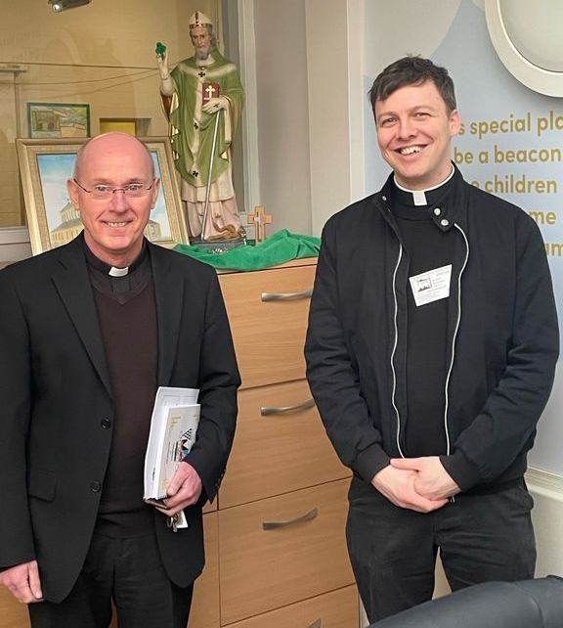
12/9/24 – Start of Year Mass in Church 9:30am;

17/9/24 - Dogs Trust in School;

30/9/24 – CAFOD in School;

7/10/24 – Black History Month Workshops in School;

10/10/24 – Hello Yellow Day for Mental Health Awareness;

14/10/24 – Y6 Retreat Day at Lowe House, St Helens

15/10/24 – Photograph Day

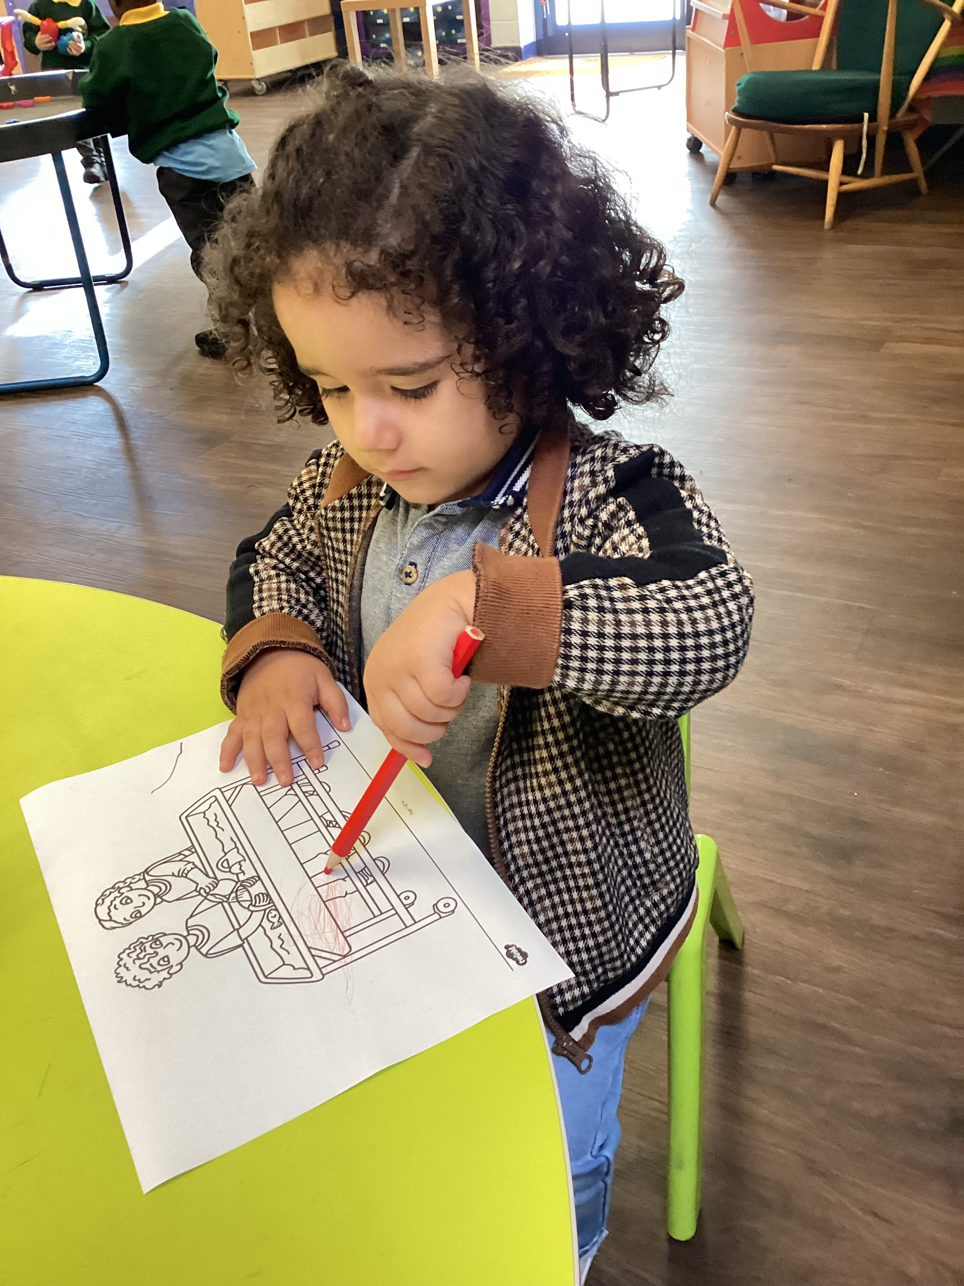
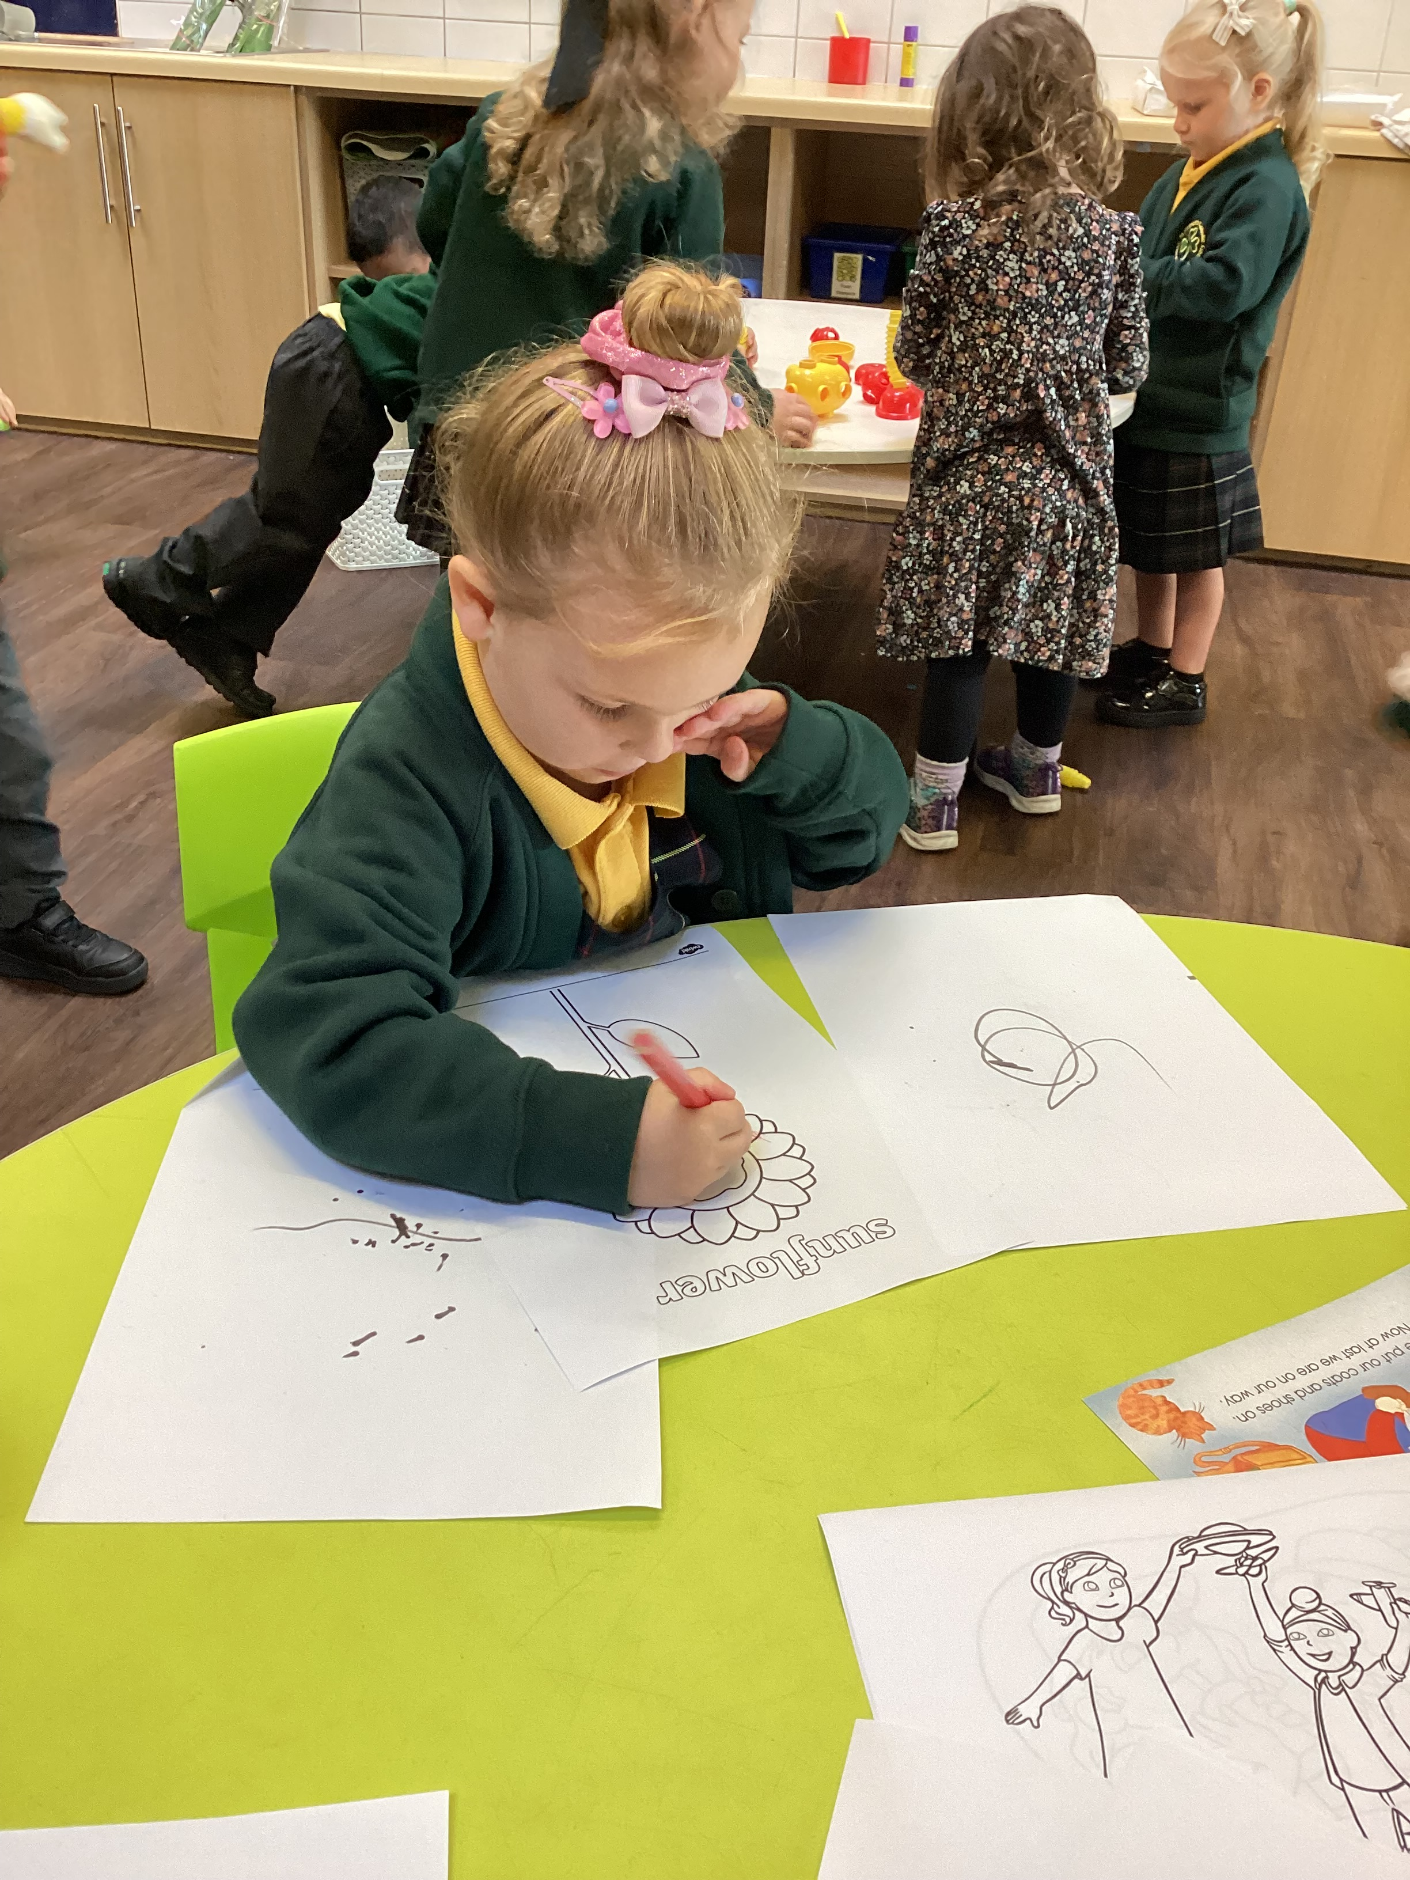
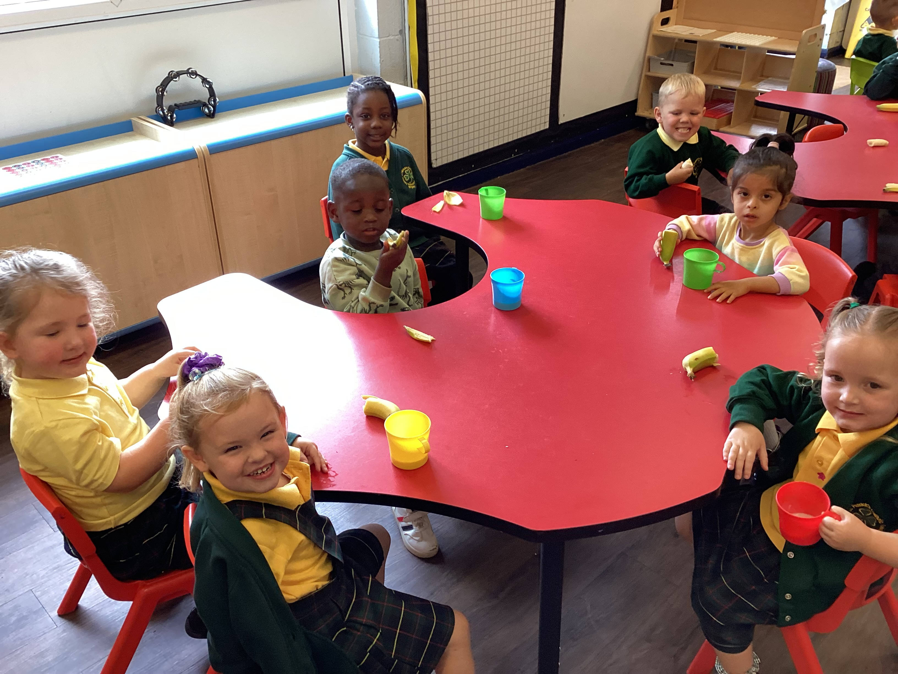

YY

Father O’Shea and Father Hugh wish all of the St Patrick’s Family a very welcome and happy return to school. If you aren’t doing so already, please like and follow the Church Facebook page for updates and information. Search for:
‘St Patrick’s Catholic Church, Wigan’



Stay and Pray Autumn 1
Wednesdays 9:05am-9:15am.
11th September – Year 6
18th September – Year 5
25th September – Year 4
2nd October – Year 3
9th October – Year 2
16th October – Year 1

